NATIONAL UNIVERSITY OF COMPUTER AND EMERGING SCIENCES (KARACHI CAMPUS)

FAST School of Computing Fall 2025



TEAM MEMBERS:
Arwa Abbas– 23K-0721 Nabira Khan– 23K-0914 Afaf Shahid - 23K-0678
SECTION:
BCS-5C
INSTRUCTOR:
Miss Atiya Jokhio
Miss Fareeha Jabeen
GITHUB LINK:
https://github.com/Arwa-Abbas/Pharmora

ABSTRACT

Pharmora is a web-based integrated pharmacy and e-commerce platform designed to connect patients, doctors, pharmacists, suppliers, and administrators in a secure and efficient digital healthcare ecosystem. The platform addresses limitations in traditional pharmacy systems such as geographical barriers, delayed prescription verification, and inefficient inventory management. Pharmora enables patients to upload prescriptions, purchase medicines online, and track orders, while doctors, pharmacists, and suppliers collaborate through automated workflows. The system ensures data security, role-based access, and real-time stock updates using a modern technology stack — React.js for the frontend, Node.js with Express.js for the backend, and PostgreSQL as the database. Pharmora aims to enhance accessibility, transparency, and operational efficiency within the pharmaceutical supply chain.

INTRODUCTION

The increasing demand for digital healthcare services has emphasized the need for reliable online pharmacy solutions that ensure prescription authenticity, medicine availability, and secure transactions. Traditional pharmacies face logistical limitations, delayed service delivery, and manual inventory management challenges.

The aim of Pharmora is to bridge this gap by creating a centralized and user-friendly web platform that integrates all stakeholders — patients, doctors, pharmacists, suppliers, and administrators.

- The motivation behind this project stems from:
- The growing reliance on online healthcare platforms post-pandemic.
- The need for prescription authenticity and digital verification to prevent misuse.
- The lack of an integrated system combining pharmacy management, supply chain control, and e-commerce capabilities.

Pharmora aspires to create a secure, scalable, and transparent platform that not only simplifies healthcare accessibility but also improves patient satisfaction and operational efficiency.

BACKGROUND (RESEARCH AND PROJECT SELECTION)

The healthcare industry has seen an accelerated transition toward digital platforms. Systems such as online pharmacies (e.g., Dawaai, Sehat, and MyPharma) have demonstrated the demand for authenticated online medicine purchasing and prescription verification. However, many lack integrated collaboration between medical practitioners, suppliers, and patients on one unified system.

During the research phase, the team analyzed existing solutions and identified the following limitations:

- Lack of verification workflow: Many platforms rely on manual prescription validation.
- Limited integration: Systems often separate the patient interface from pharmacist and supplier management.
- Inadequate automation: Few systems feature automated stock alerts or restocking notifications.
- Weak data security: Sensitive prescription and payment data are often not encrypted or role-restricted.

These observations led to the selection of Pharmora — a project that merges the strengths of digital pharmacies with the efficiency of e-commerce architecture while ensuring compliance with healthcare data security standards.

PROJECT SPECIFICATIONS

Pharmora will function as a multi-role platform with distinct dashboards for Patients, Doctors, Pharmacists, Suppliers, and Administrators.
Each user role has specific permissions and functionalities controlled by role-based access through JWT authentication.

Layer | Technology | Description
Frontend | React.js, HTML5, CSS3, Tailwind CSS | Interactive and responsive UI components
Backend | Node.js with Express.js | Server-side logic and API management
Database | PostgreSQL (Supabase) | Relational database for structured data
Authentication | JWT (JSON Web Token) | Secure and role-based user authentication
Hosting (Future Plan) | AWS / Render / Vercel | Cloud-based deployment for scalability

PROBLEM ANALYSIS (SCENARIO)

No. | Problem Identified | Cause / Root Issue | Impact on System / Users | Proposed Resolution
1 | Manual Prescription Verification | Traditional pharmacies rely on manual approval processes without automation or digital checks. | Causes delays, human error, and increased risk of fraudulent or invalid prescriptions. | Implement digital prescription verification where doctors upload prescriptions and pharmacists approve them electronically through the system.
2 | Inefficient Inventory Management | Lack of automated tracking for stock levels and expiry dates. | Results in medicine shortages, overstocking, and expired drugs remaining in circulation. | Introduce automated stock monitoring with low-stock alerts, expiry reminders, and supplier notifications for restocking.
3 | Limited Accessibility for Patients | Patients in remote areas or with mobility issues cannot easily access pharmacies. | Leads to inconvenience, delayed treatments, and poor healthcare access. | Develop a web-based platform accessible across devices, allowing patients to upload prescriptions and order medicines online.
4 | Security and Privacy Concerns | Sensitive medical and payment data are often stored without encryption or proper access control. | Increases risk of data breaches, identity theft, and loss of trust. | Apply end-to-end encryption, JWT-based authentication, and role-based access control (RBAC) for secure data handling.
5 | Lack of Integration Between Stakeholders | Separate systems for patients, doctors, pharmacists, and suppliers result in miscommunication and inefficiency. | Delays order fulfillment, verification, and stock updates. | Build an integrated multi-role system connecting all stakeholders via a centralized database and RESTful APIs.
6 | Absence of Automated Notifications | Manual communication leads to missed updates and delays in prescription approval or delivery. | Users are uninformed about order status, stock shortages, or restock requests. | Integrate automated notifications for order status, prescription updates, and stock alerts.
7 | Ineffective Reporting and Analytics | Lack of real-time reporting tools for admins to analyze system data. | Prevents decision-making related to inventory, sales, or user performance. | Implement admin dashboards with data visualization and analytical reports for insights.

PROBLEM ANALYSIS (PROJECT DEVELOPMENT)

No. | Problem Encountered | Cause / Reason | Impact on Development | Solution / Resolution Implemented
1 | Database Relationship Conflicts | During the creation of ERD, some relationships between entities (e.g., users, prescriptions, and orders) caused circular dependency and data redundancy. | Delayed database design and schema finalization; caused errors during table linking. | Revised the ERD to follow 3rd Normal Form (3NF), ensuring foreign keys were properly defined and redundant data removed.
2 | API Integration Errors | Mismatch between frontend and backend API endpoints due to inconsistent naming conventions and request formats. | The frontend could not fetch or send data properly; caused authentication and data retrieval failures. | Standardized all API routes and implemented Postman testing before integration; maintained a shared API documentation.
3 | Authentication and Role-Based Access Issues | Implementing JWT authentication for multiple roles (patient, doctor, pharmacist, admin) caused token mismanagement and access overlaps. | Unauthorized access to certain routes during early testing; users occasionally received wrong privileges. | Created separate middleware functions for each user role and validated tokens server-side for every protected route.
4 | Frontend State Management Complexity | Managing state for different user dashboards and components in React became confusing as the project grew. | Data inconsistency across components; duplicate API calls and slow performance. | Introduced React Context API for global state management and optimized API usage through caching.
5 | Styling and Responsiveness Issues | Using Tailwind CSS required adjustment to ensure consistency across devices and browsers. | Pages appeared misaligned on smaller screens and components overlapped in some views. | Implemented responsive design principles, tested layouts on multiple screen sizes, and used Tailwind’s grid and flex utilities consistently.
6 | Payment Gateway Integration Challenges | Sandbox testing for Stripe and PayPal APIs was difficult due to region restrictions and configuration errors. | Payment verification and redirection failed during testing. | Shifted to test mode credentials, verified callback URLs, and added a backend route to confirm transactions securely.
7 | Version Control Conflicts | Multiple developers working on different branches caused Git merge conflicts and overwritten code. | Lost progress during merges; delayed feature integration. | Adopted Git branching strategy (feature branches + pull requests) and maintained commit discipline with clear messages.
8 | Deployment Environment Configuration | Differences between local and cloud environments (Node.js versions, ports, and database connection URLs) caused runtime errors. | Backend failed to connect to database during initial deployment attempt. | Created a .env configuration file, standardized environment variables, and tested deployment using local Docker simulation.
9 | Testing and Debugging Difficulties | Lack of automated testing initially led to manual error tracking, which was time-consuming. | Missed minor bugs and inconsistent test coverage across modules. | Added Jest and Postman test suites for automated endpoint validation and functional testing before final submission.
10 | Time Constraints and Task Overlaps | Coordinating tasks among three members while balancing academic workload was challenging. | Delays in integration phase and report documentation. | Created a shared project timeline and Trello board, reallocated workload, and implemented weekly progress reviews.

SOLUTION DESIGN

System Overview

Pharmora’s architecture ensures all entities interact through a centralized database and backend API layer.

System Roles & Functionalities
Patient
- Register and log in securely.
- Upload prescription images or PDFs.
- Browse and purchase medicines online.

Doctor
- Issue and digitally sign prescriptions.
- View patient prescription history.
- Verify prescription authenticity.

Pharmacist
- Manage and update medicine inventory by requesting stock from any supplier.
- Receive delivery notifications when suppliers fulfill stock requests.
- Track statuses for deliveries.

Supplier
- Respond to restock requests from pharmacists.
- Manage supplied medicine details and status, including shipping.
- Ensure consistent supply by delivering stock to pharmacists and sending notifications when deliveries are completed.

Administrator
- Manage user accounts – edit, or deactivate users.
- Generate analytical reports (csv format) – track sales, user role history, and medicine inventory.
- Oversee system compliance and handle escalations.
- Monitor key metrics via dashboard – view total revenue, number of users, orders, and other system statistics.

System-Level Functionalities

- Automated Notifications
- Role-Based Access Control (RBAC) using JWT tokens.
- Encrypted data storage for all user and transaction data.
- Audit Logging for system monitoring.

DATABASE DESIGN

The database follows a relational model for consistency and normalization.

Key Entities
- Users (Patients, Doctors, Pharmacists, Admins)
- Suppliers
- Medicines
- Prescriptions
- Orders

Entity Relationship Diagram (ERD)

(ERD created in draw.io has been attached with the project submission)

Explanation:

- One-to-many relationships exist between Suppliers → Medicines, Doctors → Prescriptions, and Patients → Orders.
- Prescriptions link patients and doctors to verified medicine purchases.
- Orders reference Prescriptions when applicable and include medicine items through junction relationships.

IMPLEMENTATION AND TESTING PHASE

Pharmora was implemented using the PERN Stack — PostgreSQL for secure data storage, Express.js and Node.js for backend logic, and React.js for the dynamic, user-friendly frontend. The project followed a modular architecture to separate concerns between database management, API functionality, and user interface, ensuring scalability and maintainability.

The backend API, built with Express.js, handled all core operations such as user authentication, product management, order processing, and communication between clients and pharmacists. PostgreSQL was used to design normalized relational schemas for storing users, medicines, and order details securely. Node.js facilitated asynchronous operations for handling multiple requests efficiently, while environment variables managed sensitive configurations securely.

The frontend, developed using React.js, provided responsive pages for login, registration, browsing medicines, placing orders, and managing prescriptions. Tailwind CSS ensured consistent and modern styling, and Axios enabled smooth API communication between the client and server.

Testing was conducted across multiple levels to ensure performance, reliability, and data integrity:
- Unit Testing validated backend routes, database queries, and authentication functions to confirm accurate input handling and response behavior.
- Integration Testing verified end-to-end interactions between frontend and backend, ensuring smooth data exchange between API endpoints and UI components.
- Functional Testing ensured that user registration, login, and order placement workflows operated correctly across various scenarios.
- Database Testing confirmed proper schema relations, query performance, and data persistence for all CRUD operations.
- User Acceptance Testing (UAT) involved simulated end-user interaction to confirm intuitive navigation, responsive design, and overall usability.

Overall, the PERN-based architecture of Pharmora provided a secure, efficient, and responsive platform for managing pharmacy operations, from inventory tracking to order fulfillment

PROJECT BREAKDOWN STRUCTURE

Phase | Task | Assigned Member(s) | Duration
Phase 1 | Research & Requirement Analysis | Afaf, Arwa, Nabira | 2 weeks
Phase 2 | Database & ERD Design | Arwa, Nabira | 1 week
Phase 3 | Frontend Development | Afaf, Nabira | 3 weeks
Phase 4 | Backend API Development | Arwa | 3 weeks
Phase 5 | Integration & Testing | Entire Team | 2 weeks
Phase 6 | Report Writing & Presentation | Entire Team | 1 week

OUTPUT SCREENSHOTS

Home Page

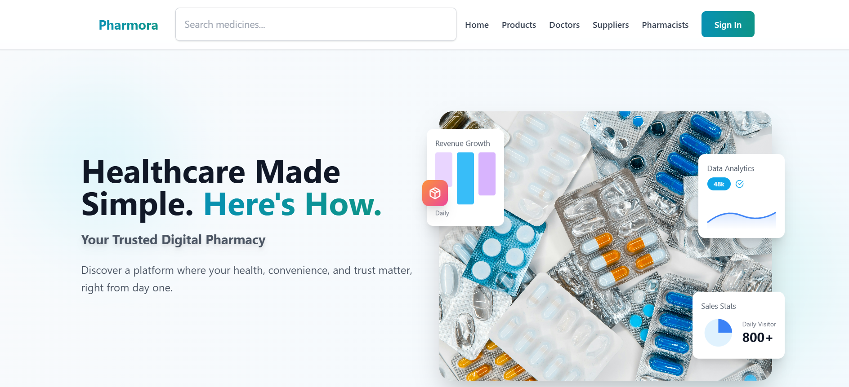
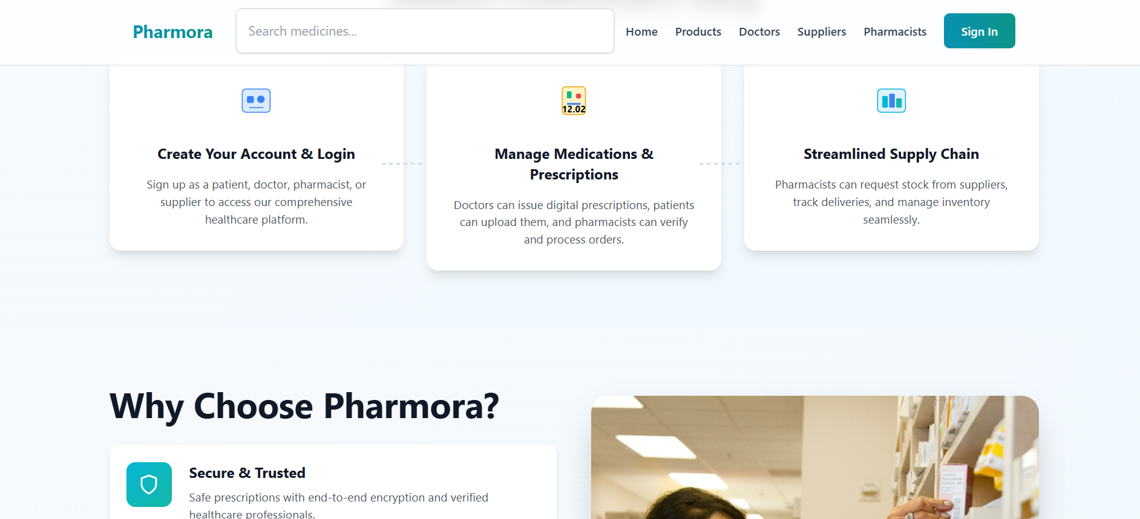

Search Medicine
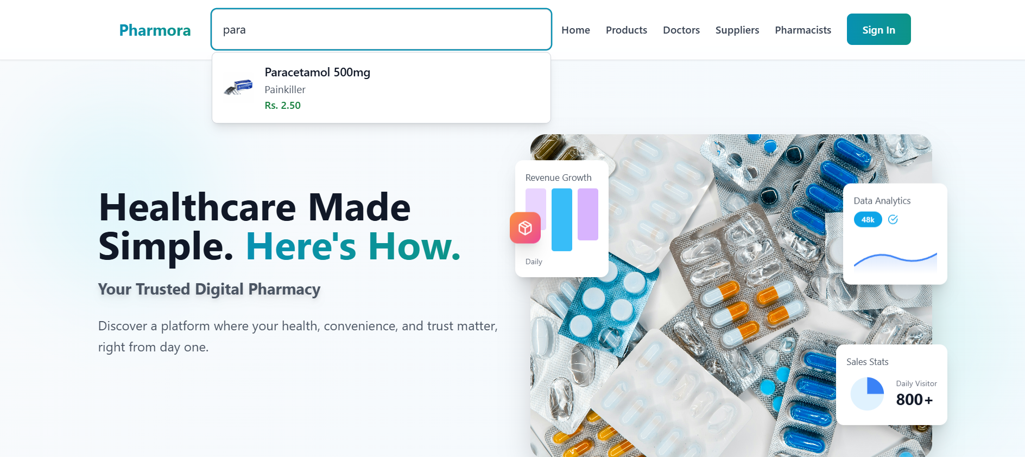

Products/Medicines Tab
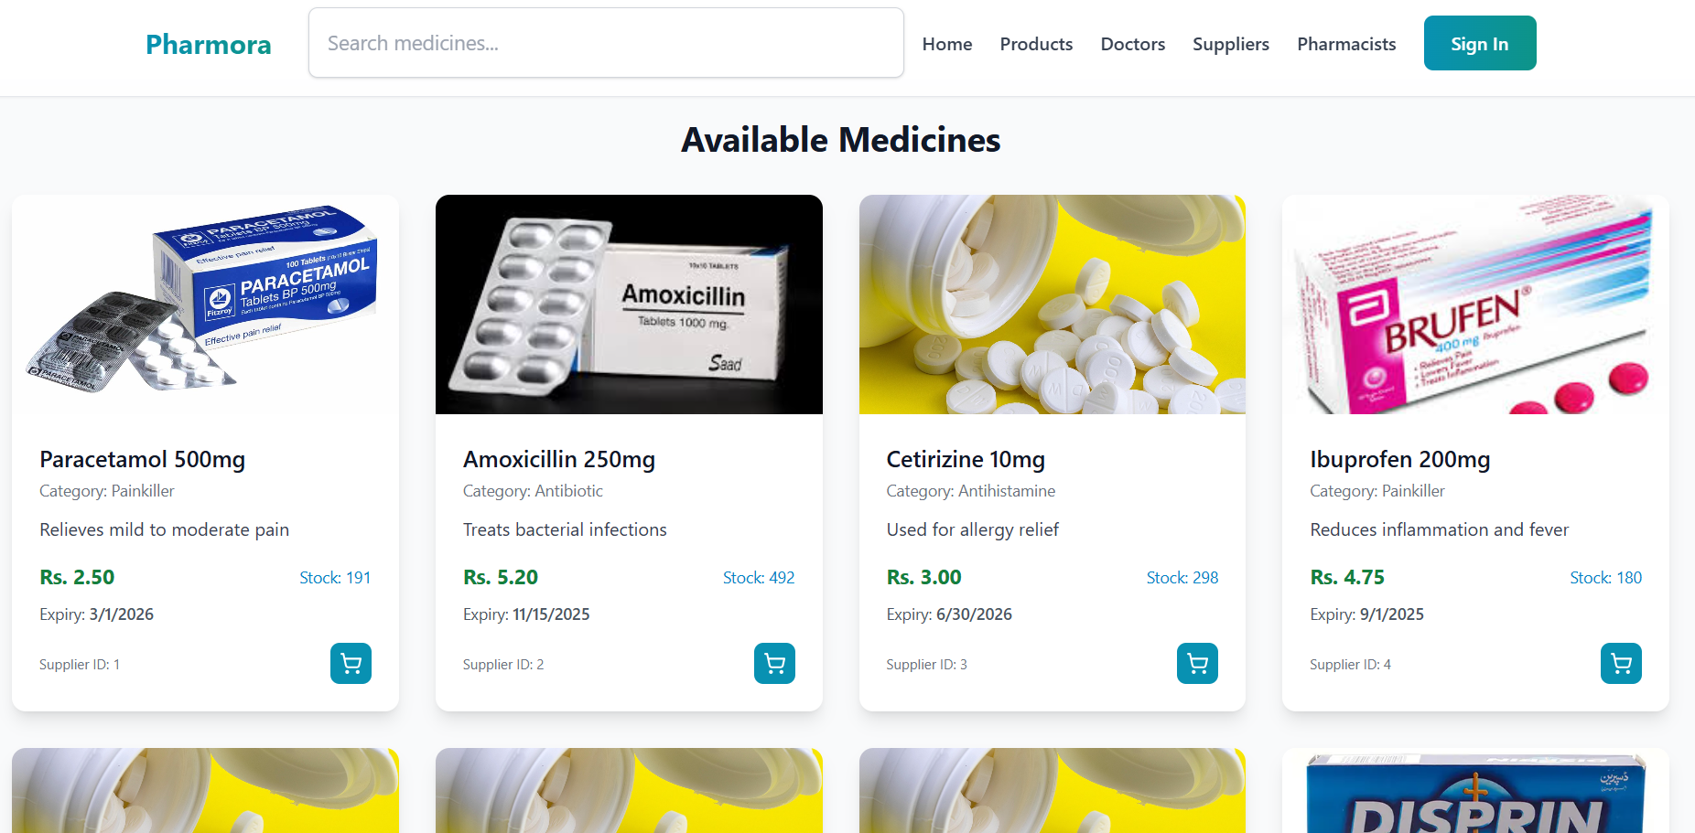

Doctors Tab
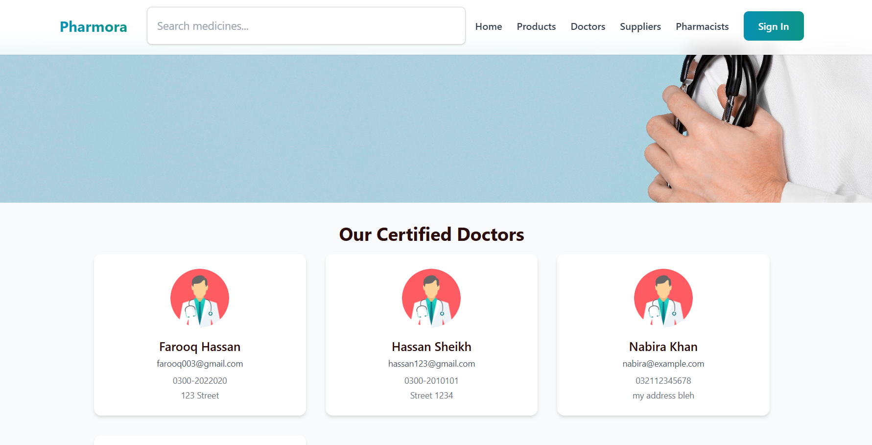

Suppliers Tab
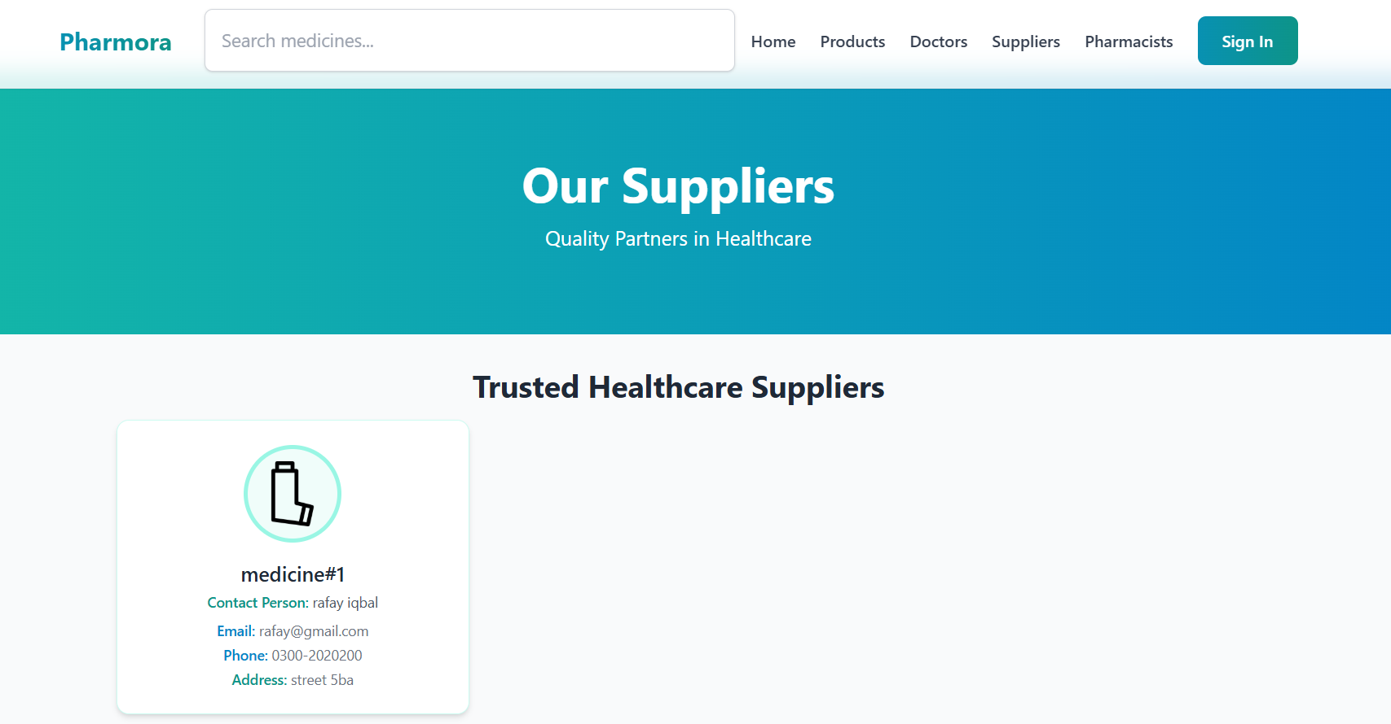

Pharmacist Tab
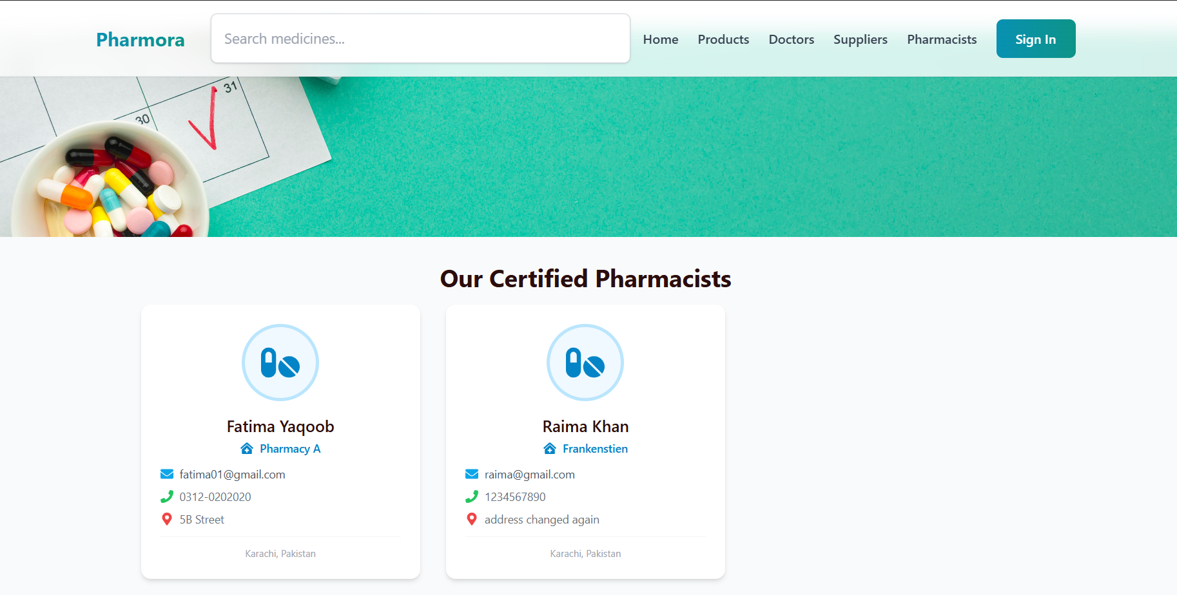

Sign In
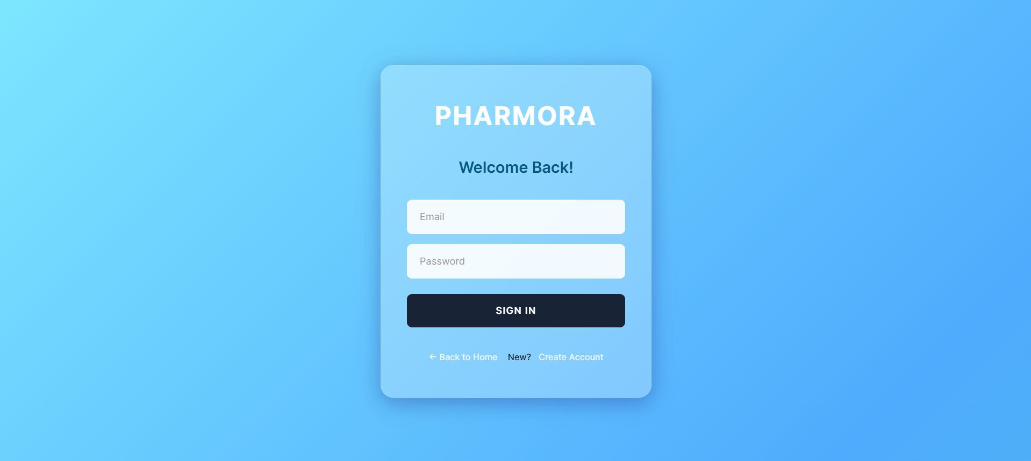

Create Account
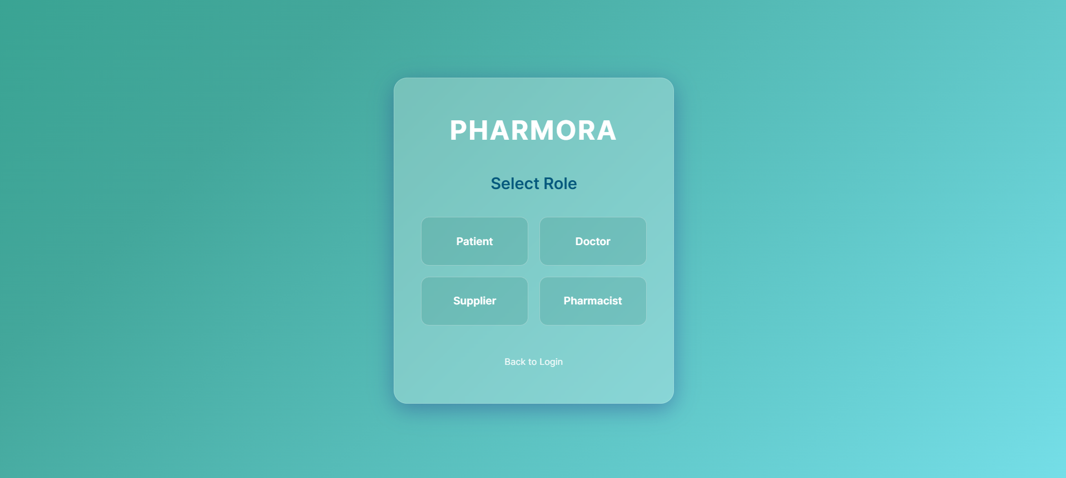
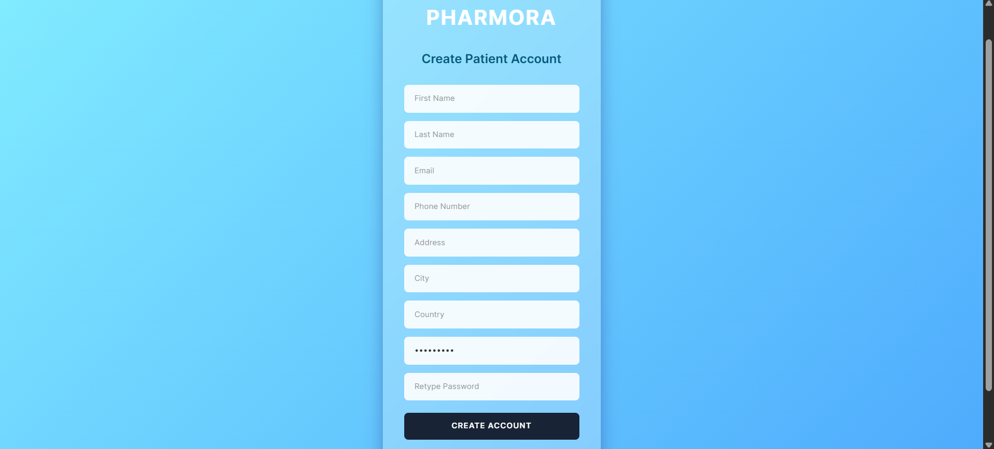

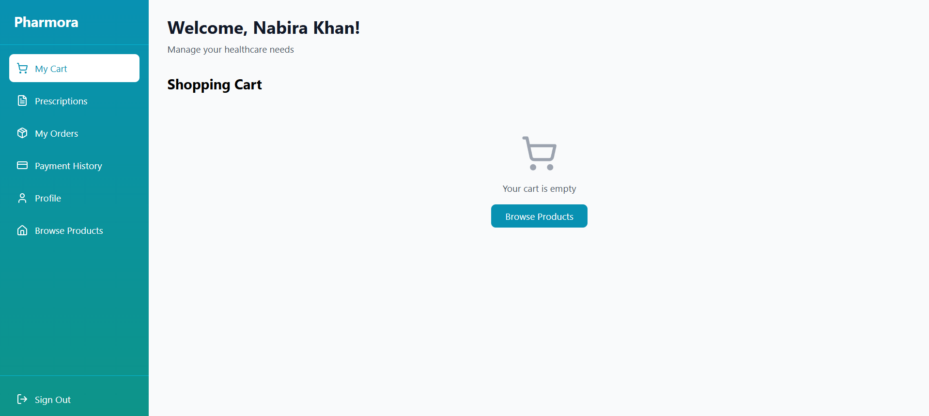
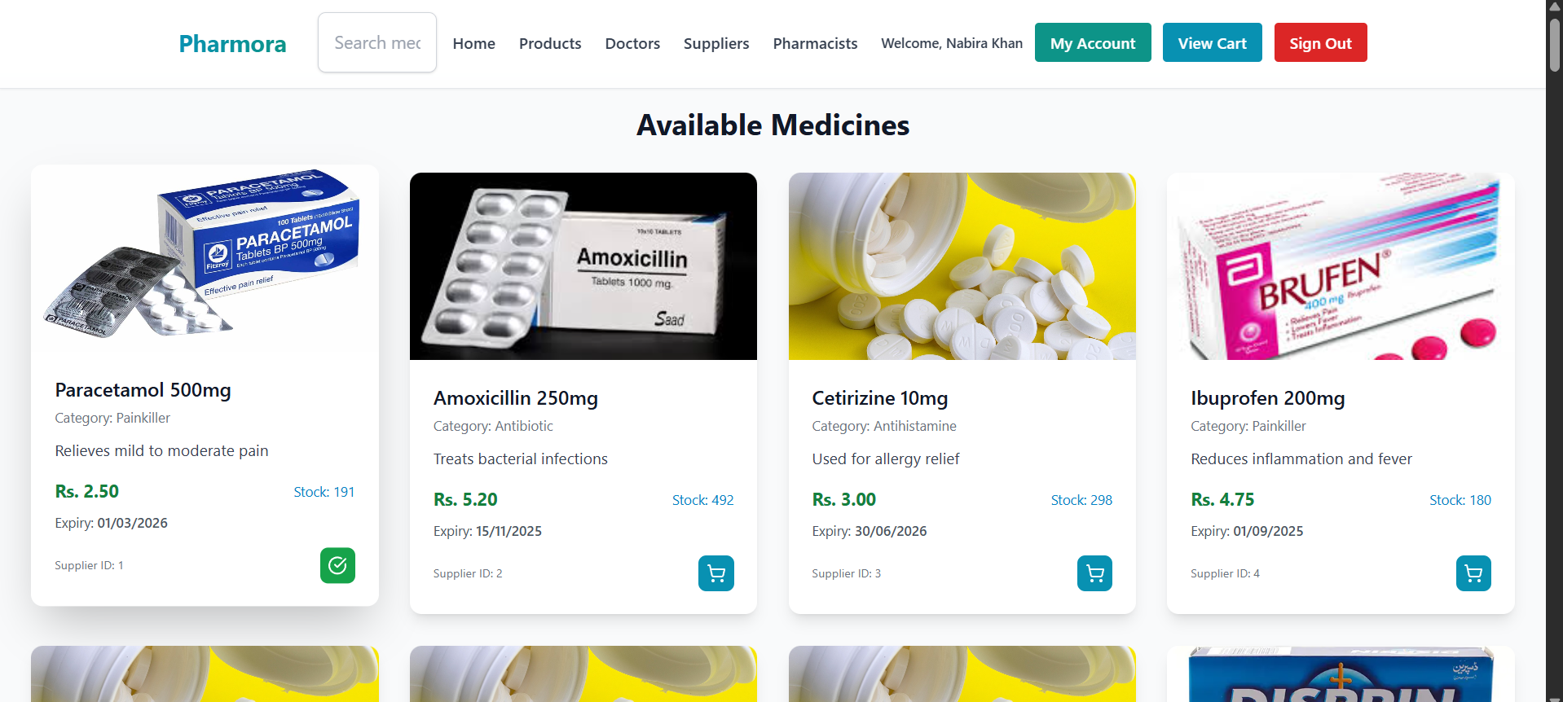
Patient Dashboard


Add to Cart

View Cart
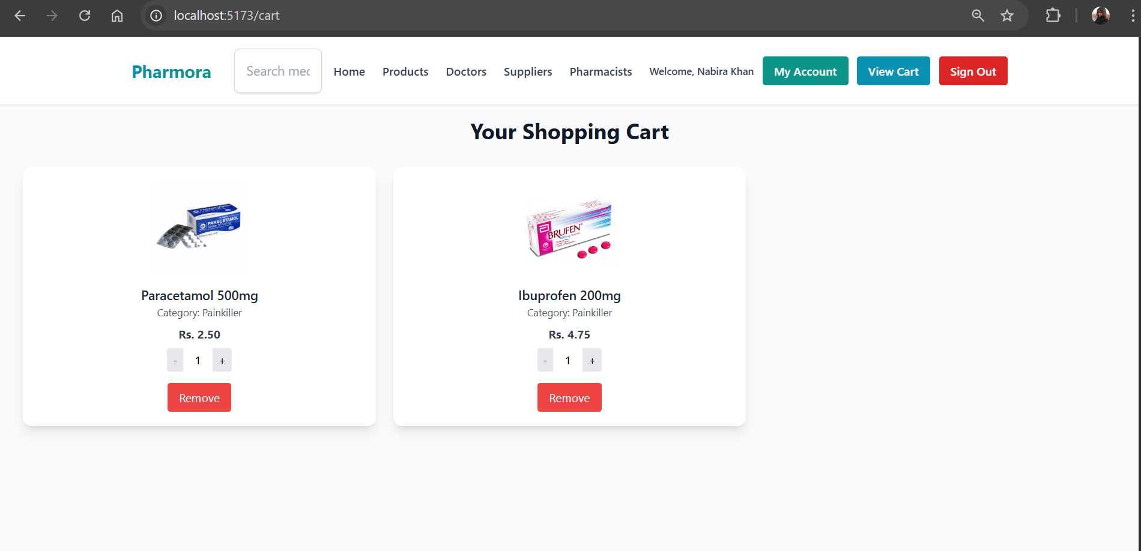
Place Order

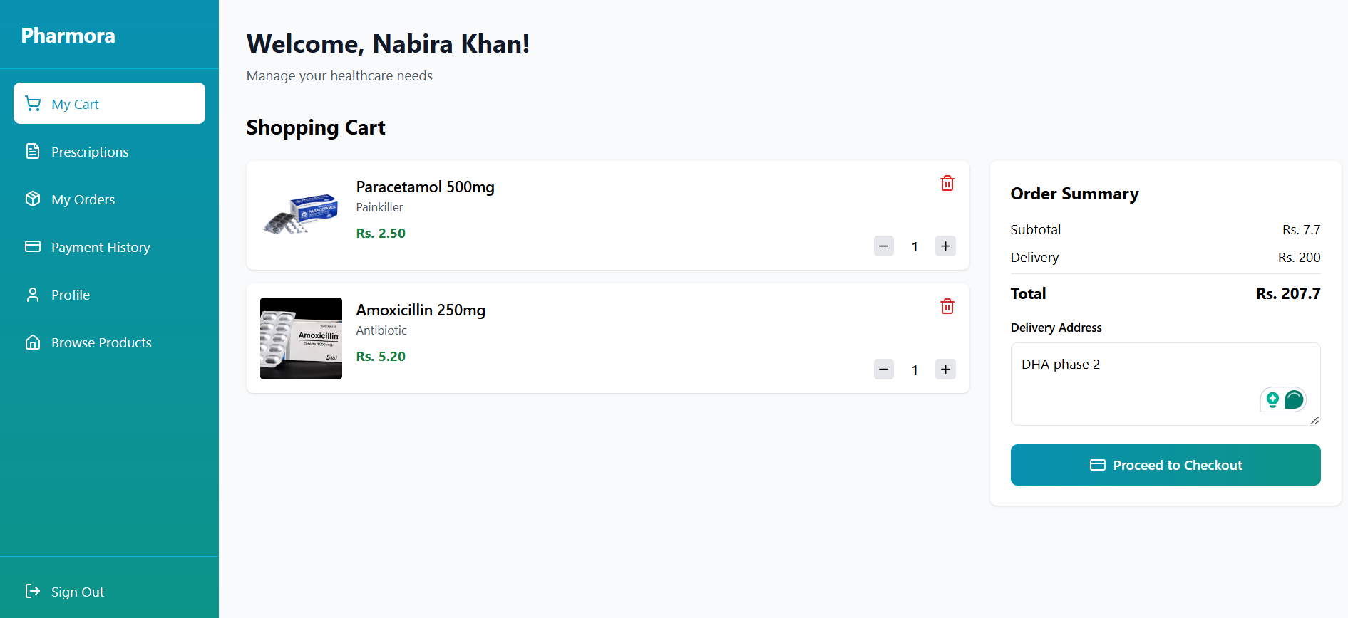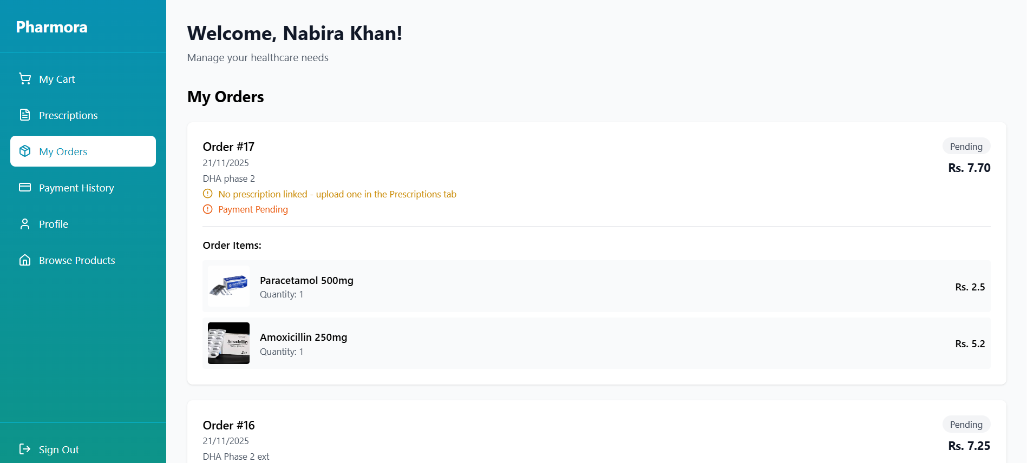

Add Prescription + Make Payment
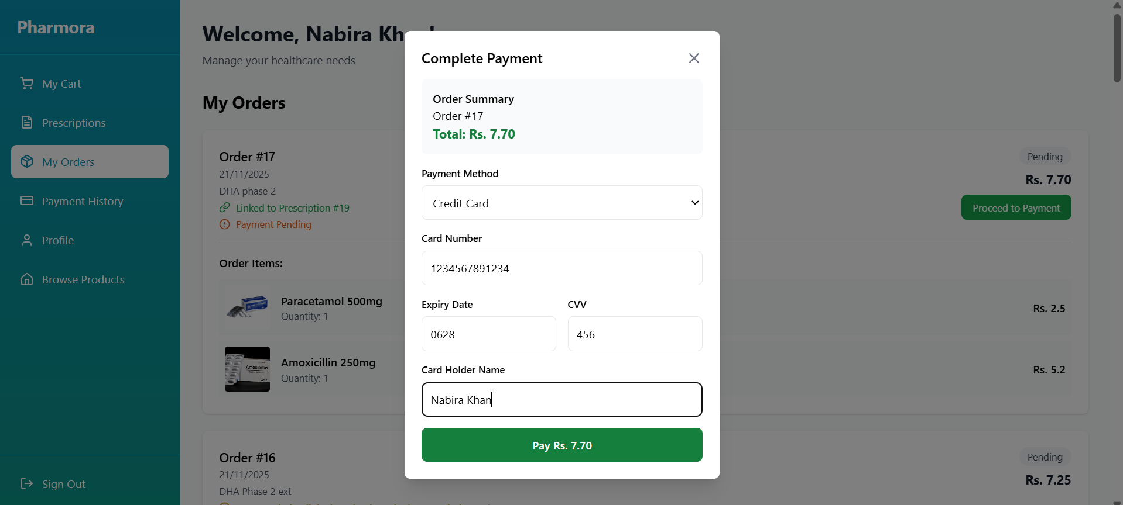
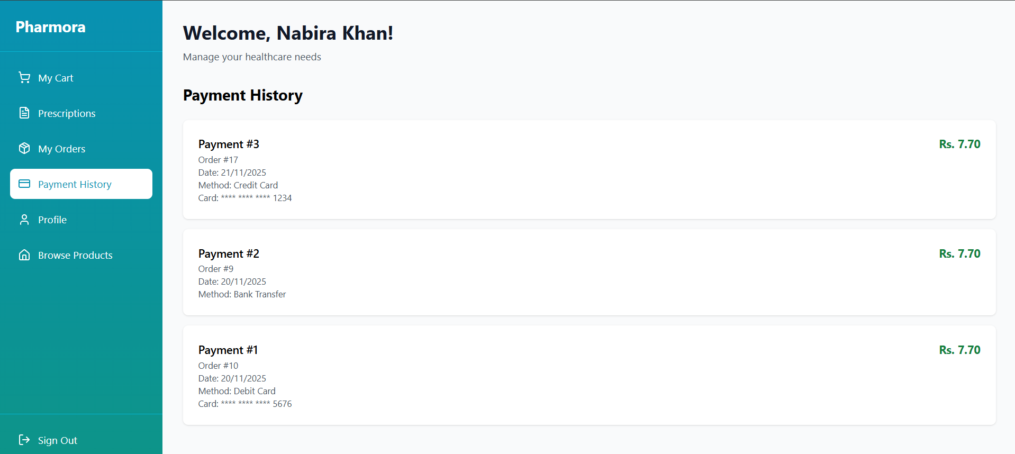
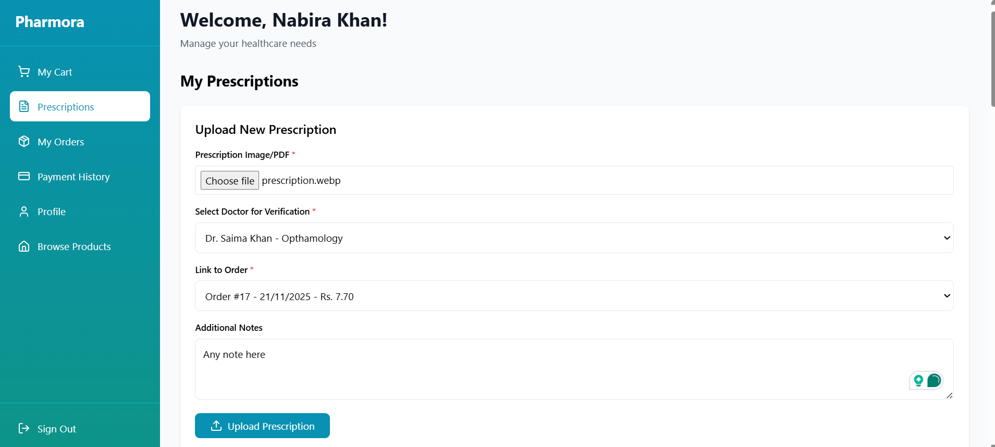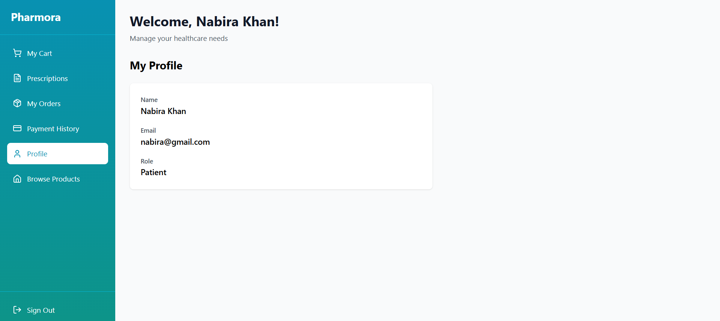
Doctor Dashboard

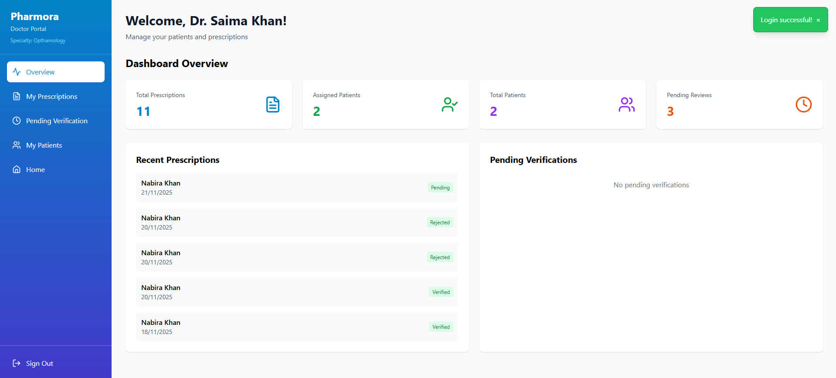

Verify Prescription

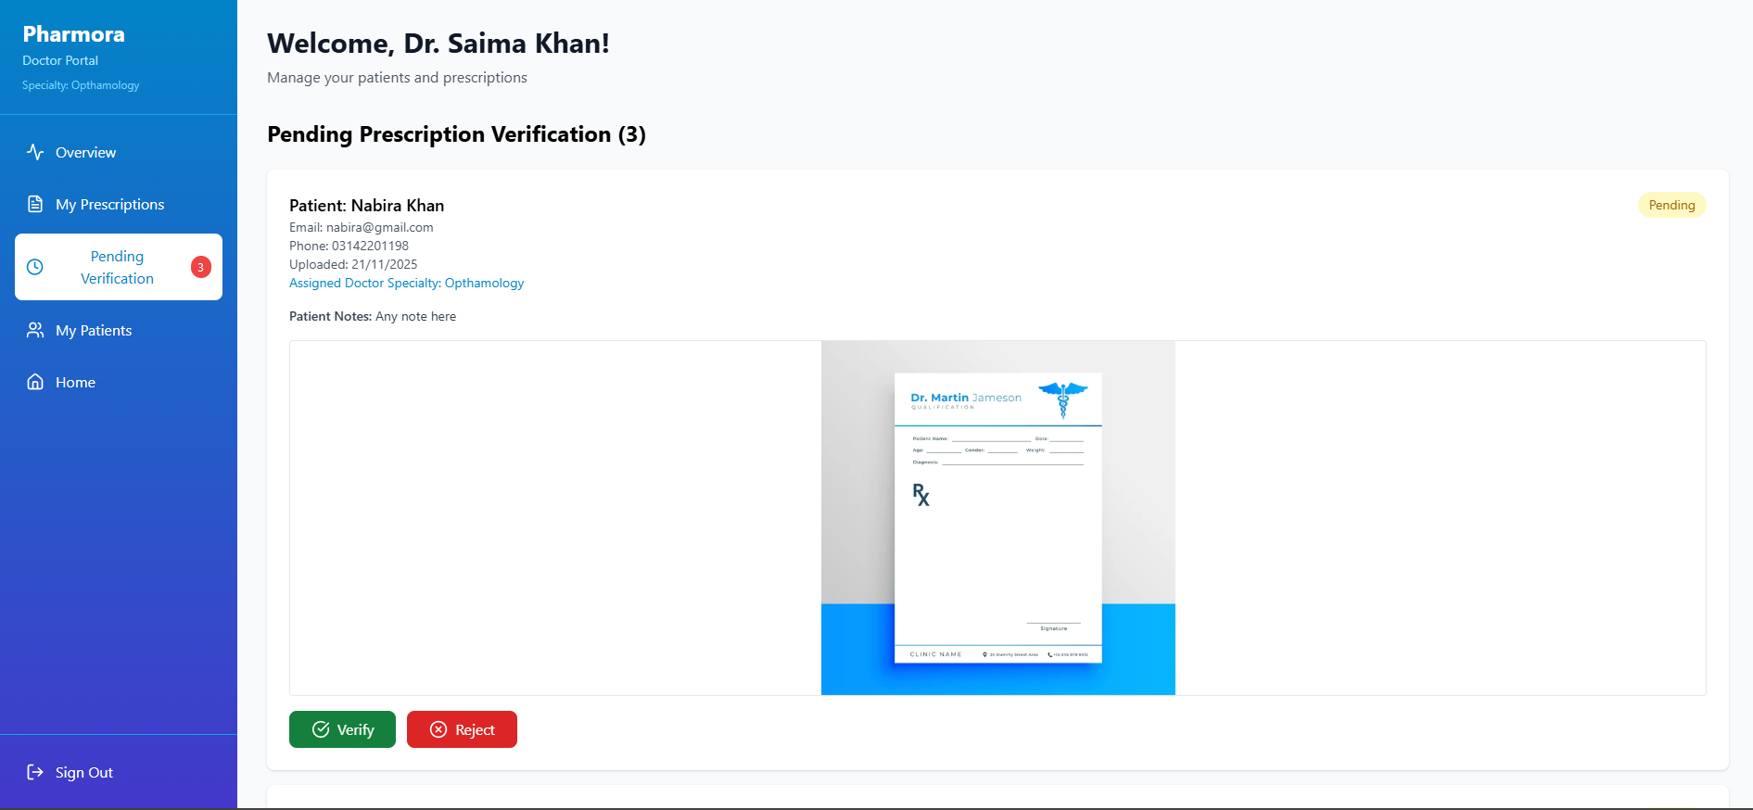

Create Prescription
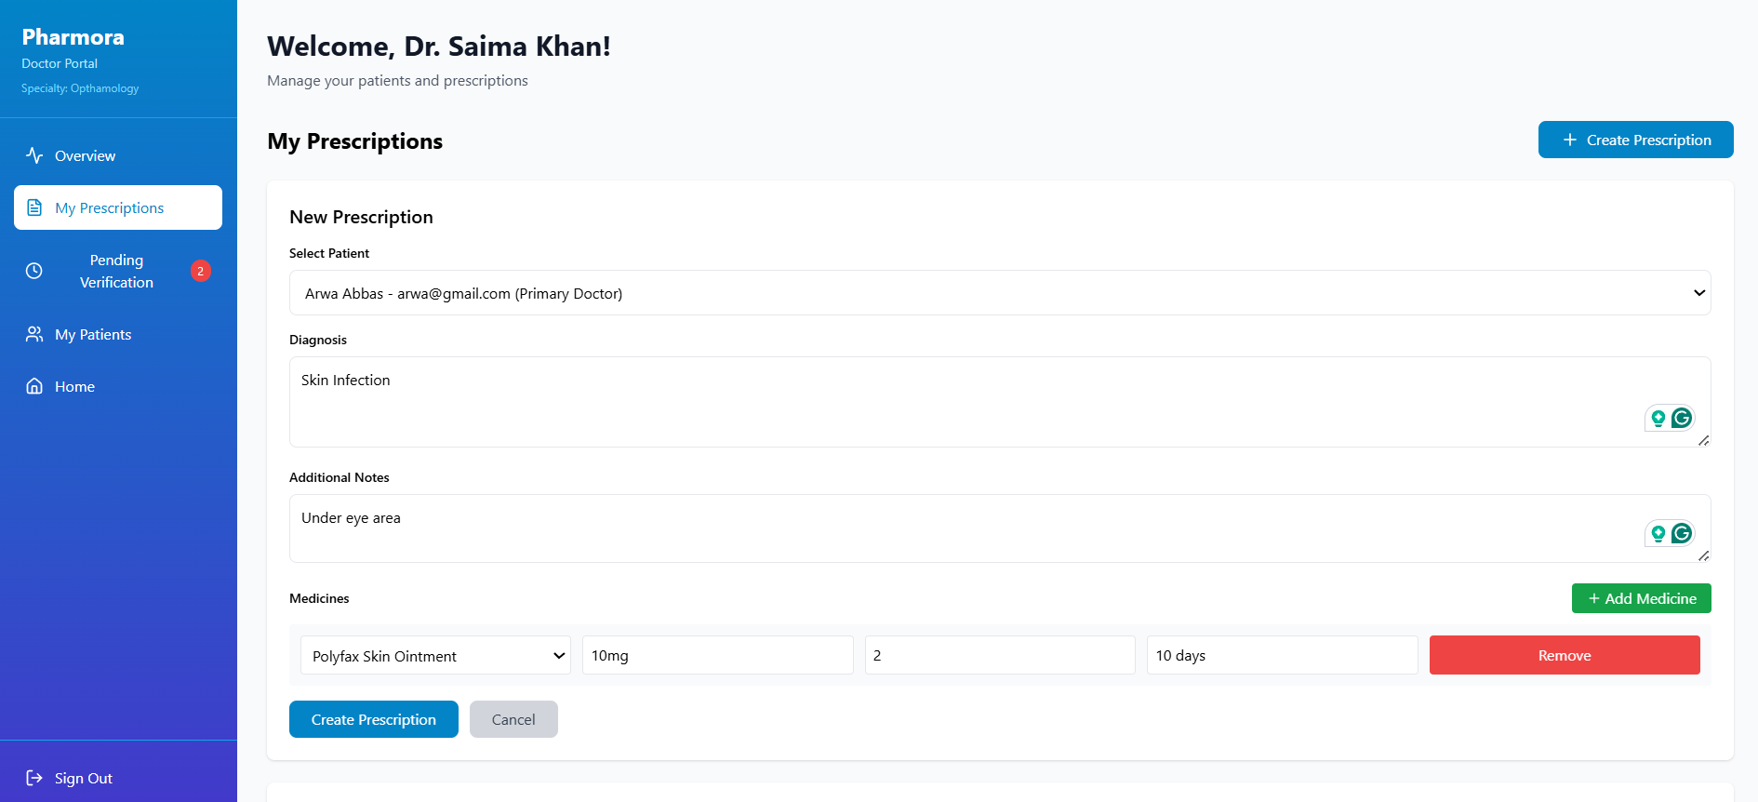

My Patients Dashboard

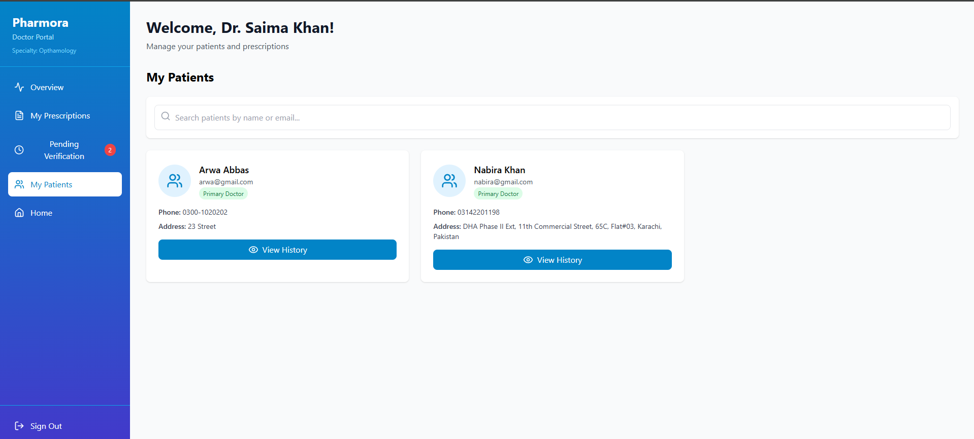

Patient History
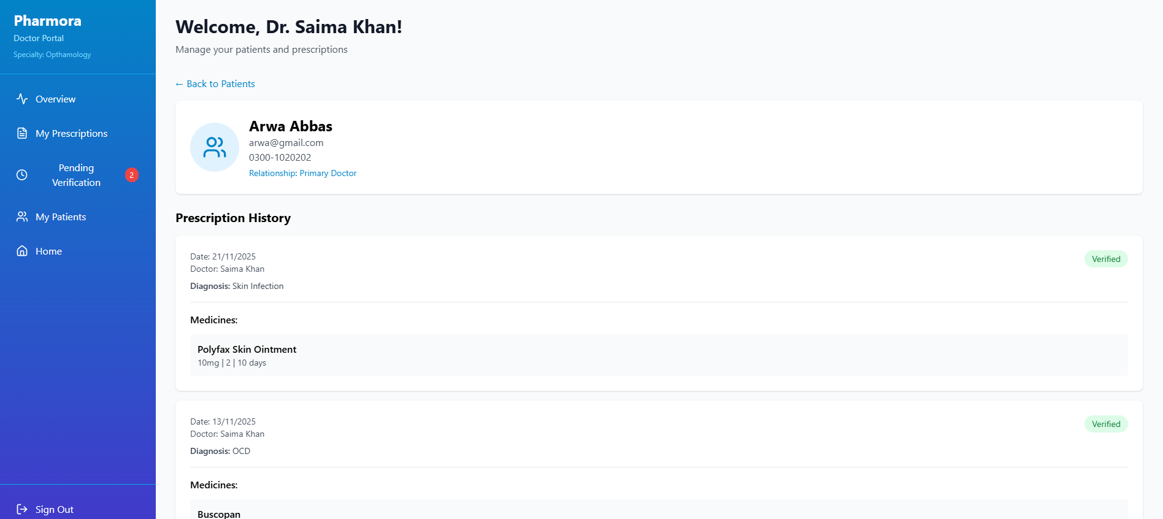

Pharmacist Dashboard
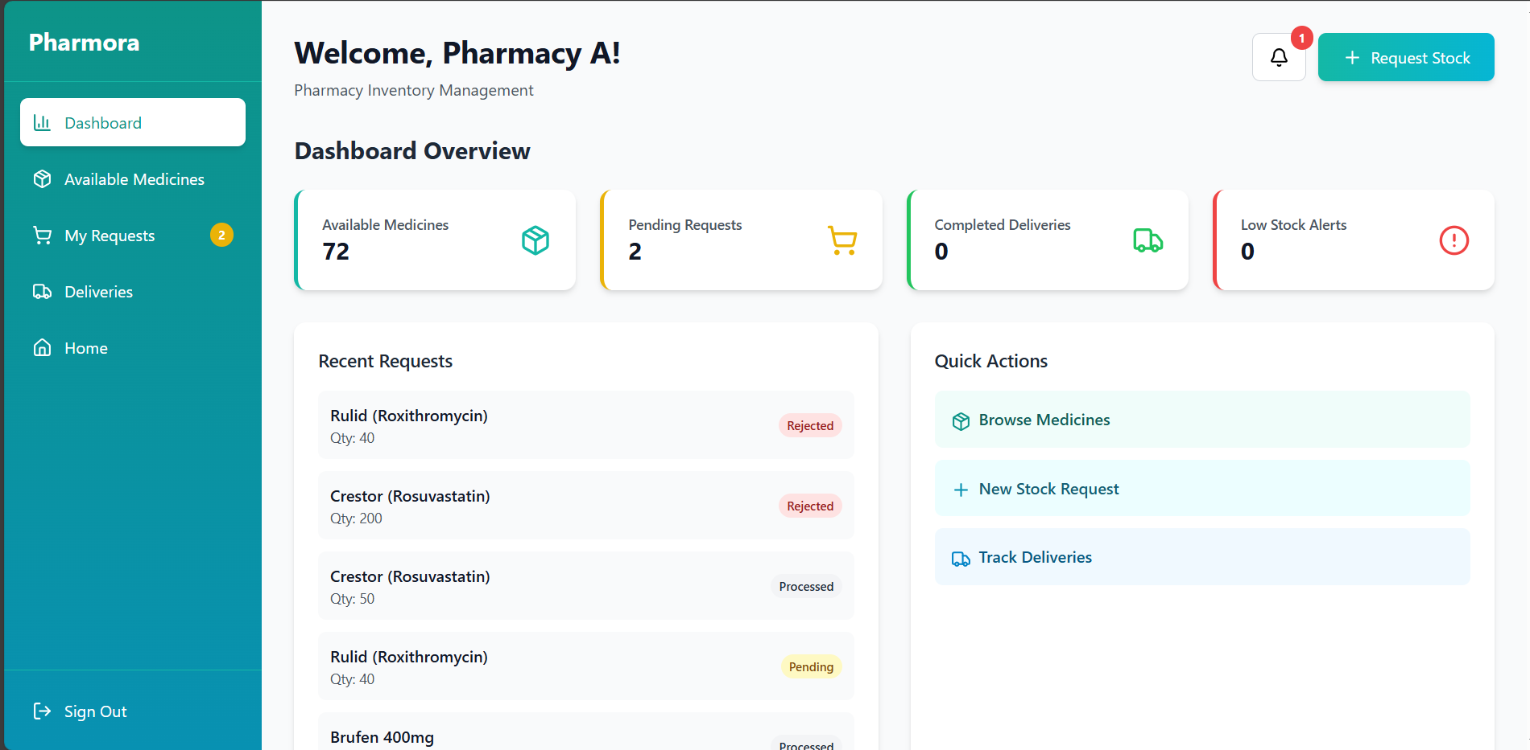

Available Medicine Tab
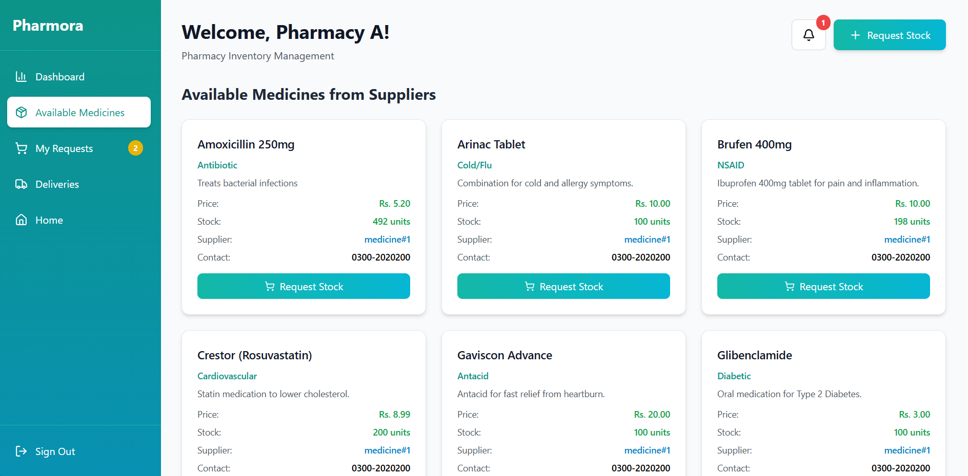

My Requests Tab
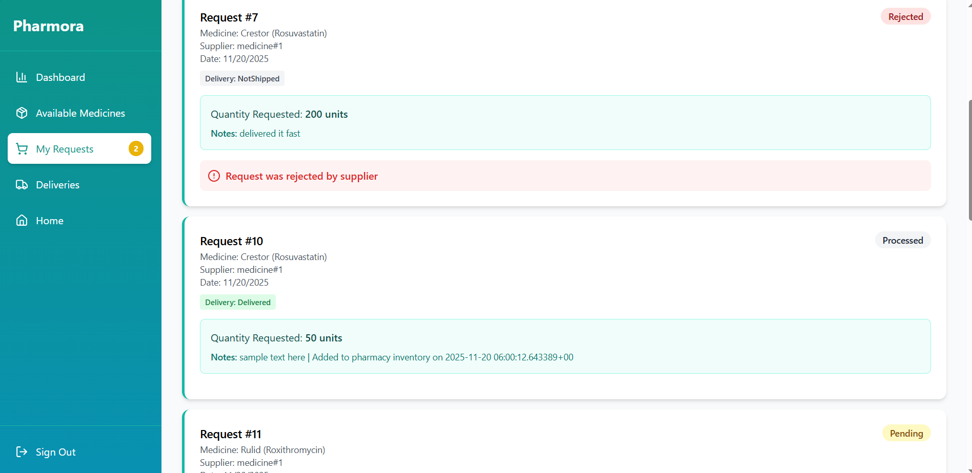

Stock Request

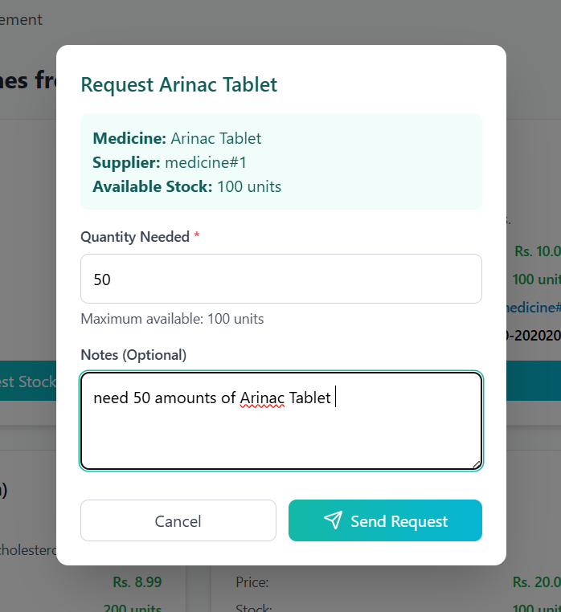

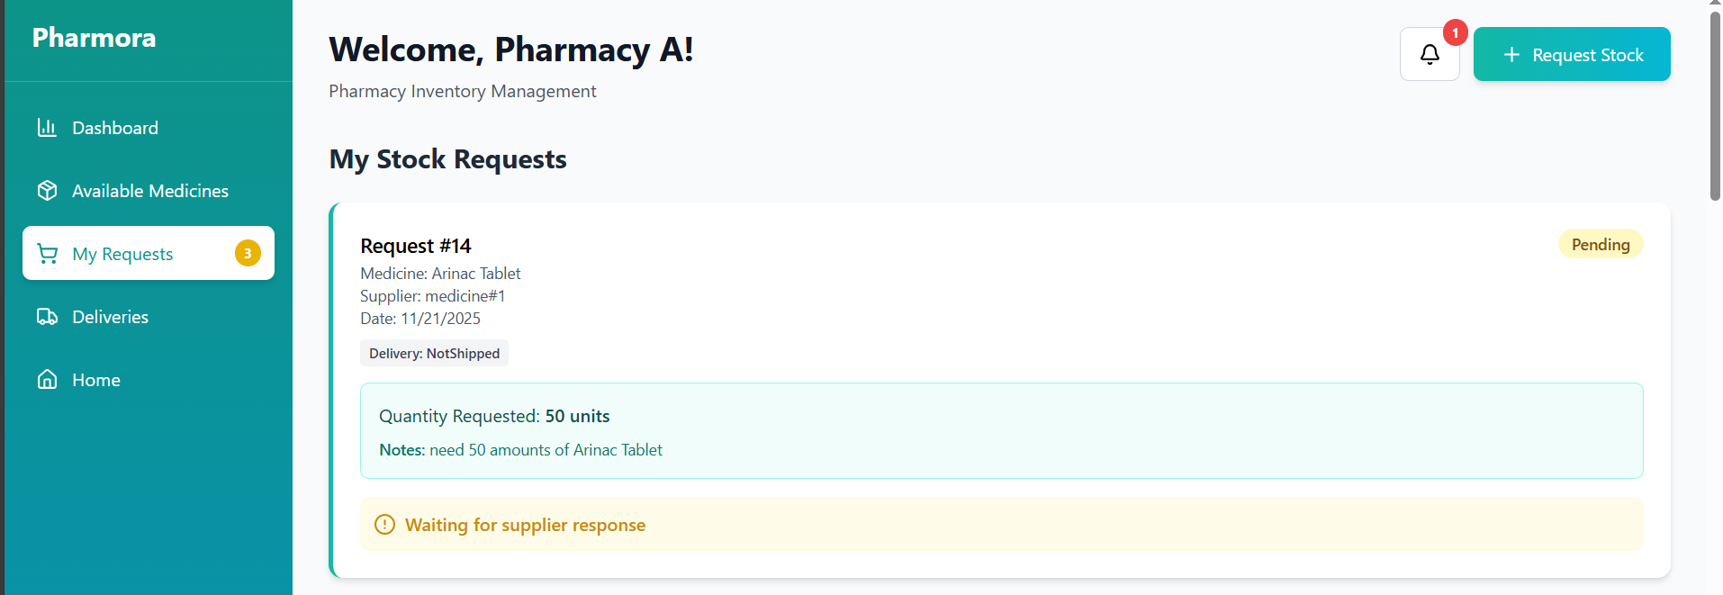

Supplier Dashboard
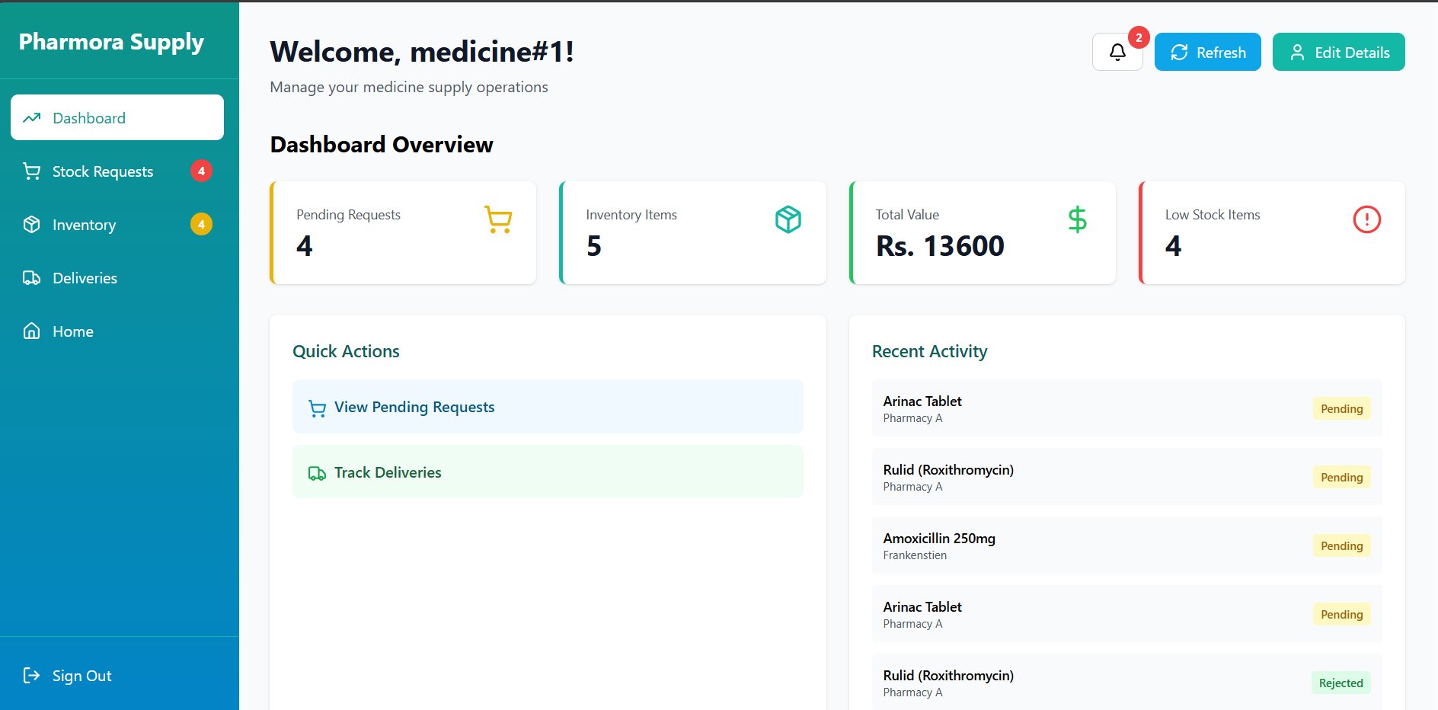

Stock Requests Tab
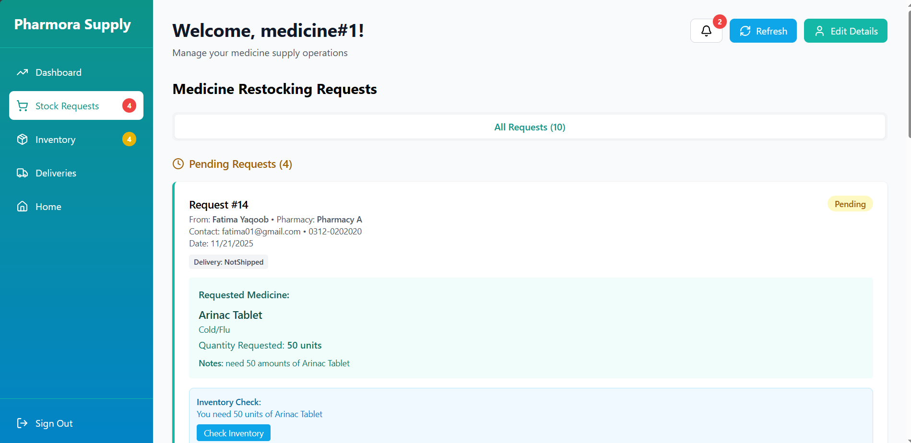

Inventory Tab
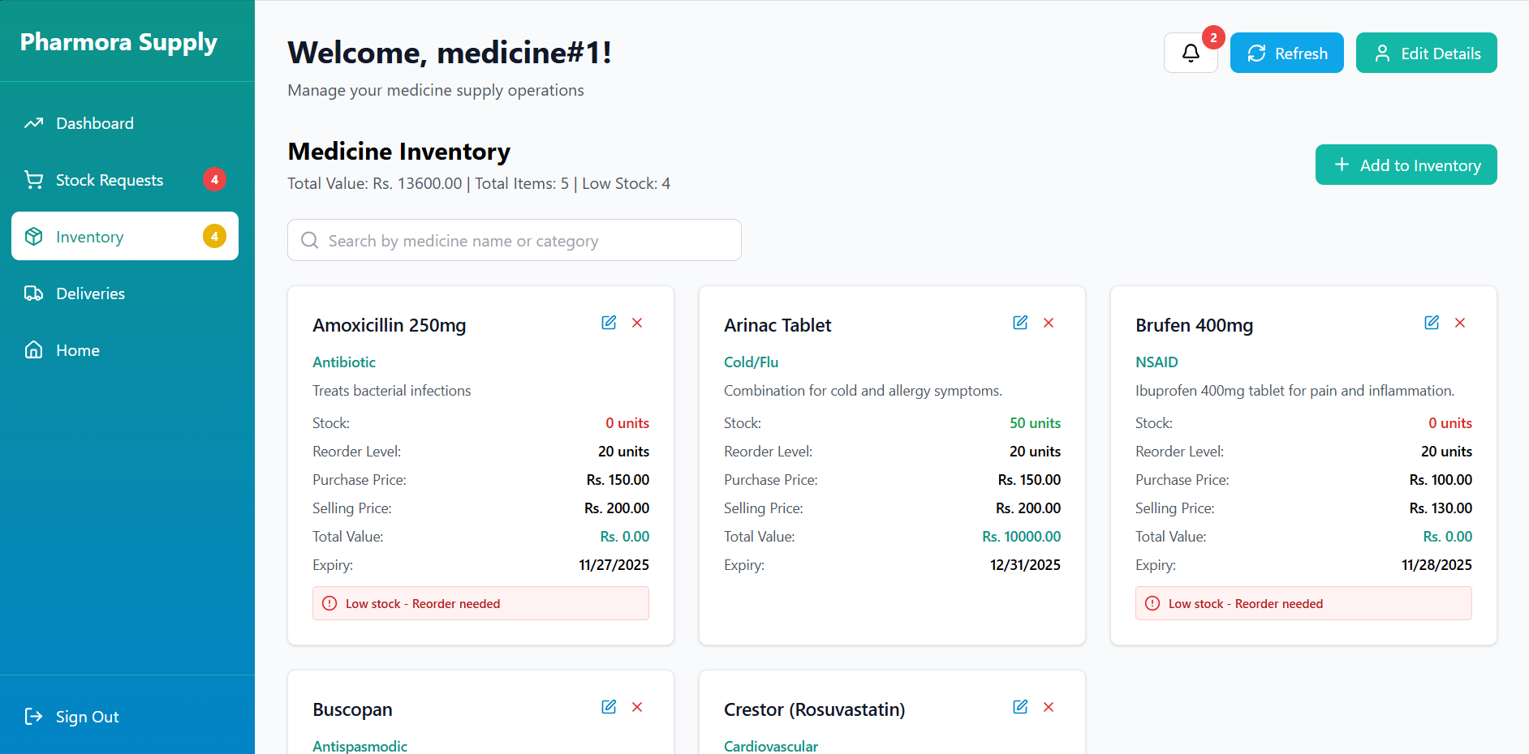

Deliveries Tab
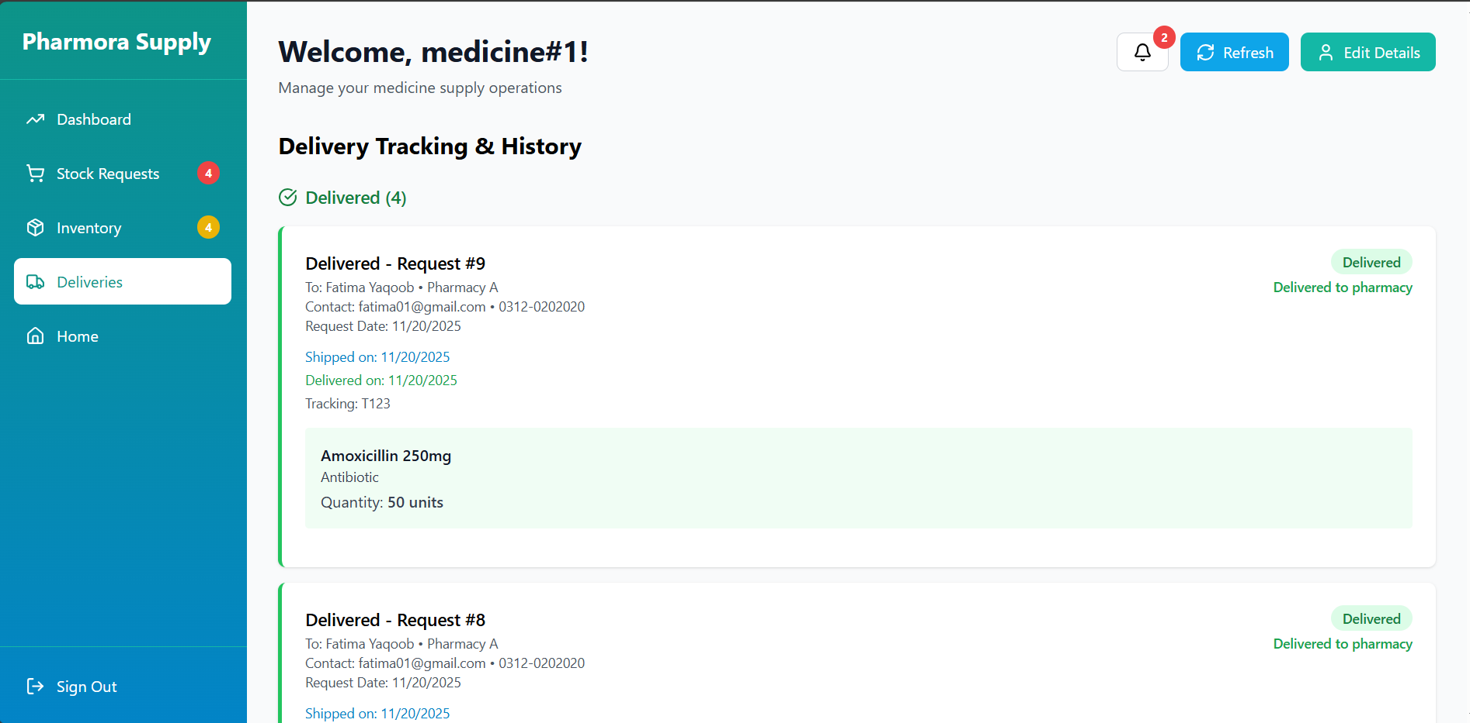

Accept Stock Request (Inventory Checking)
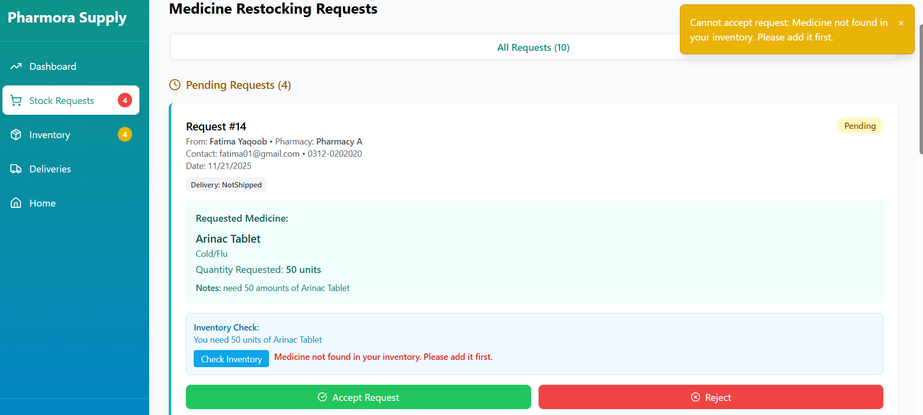

Add Medicine to Supplier’s Inventory
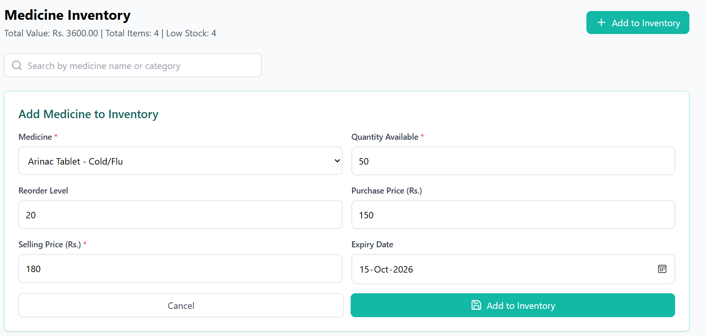

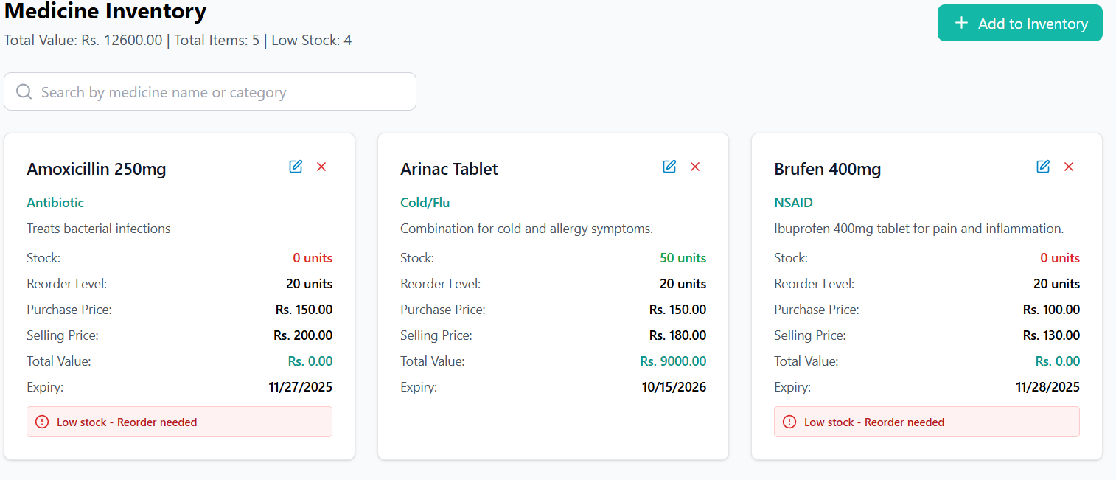

Accept Stock Request
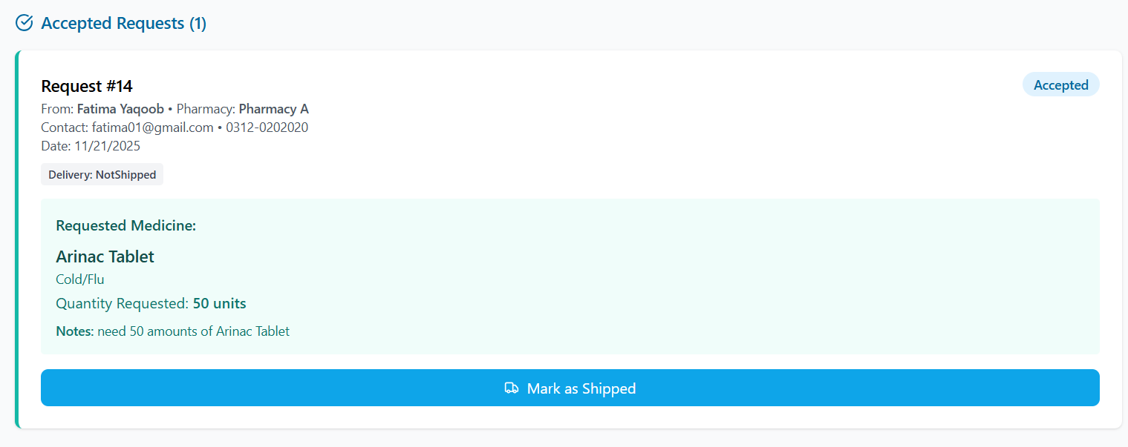

Shipped Requested Medicine
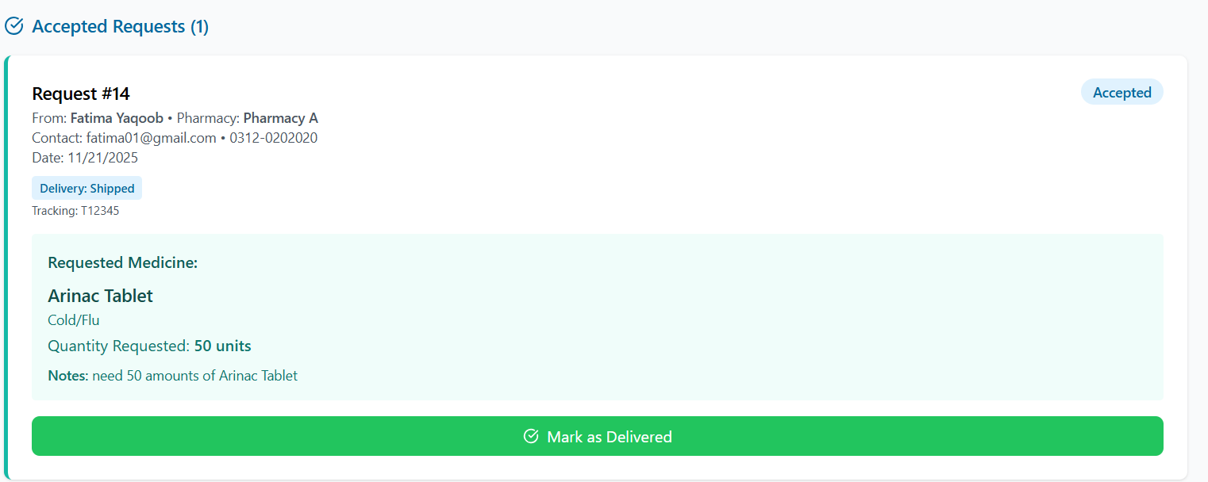

Deliver Requested Medicine
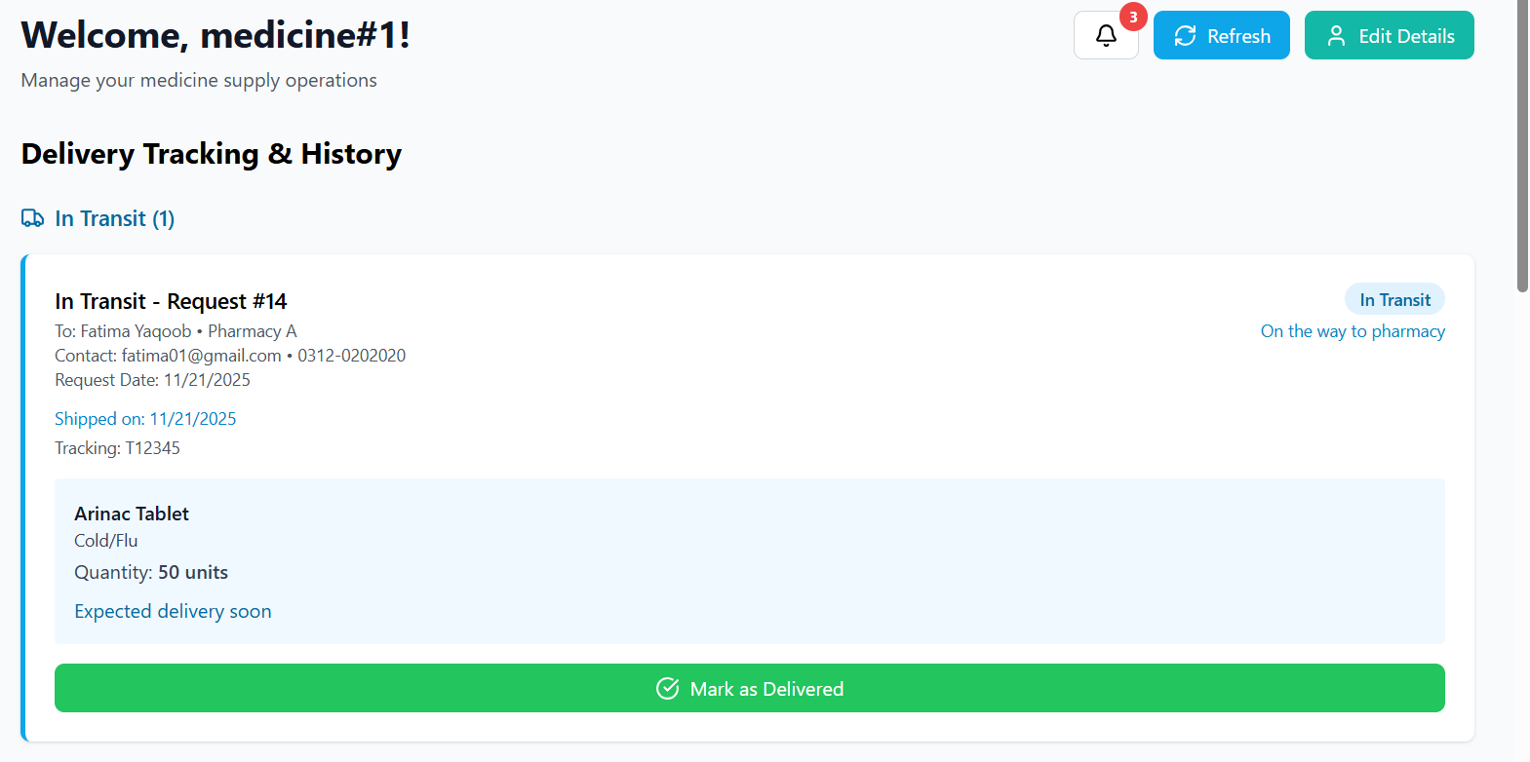
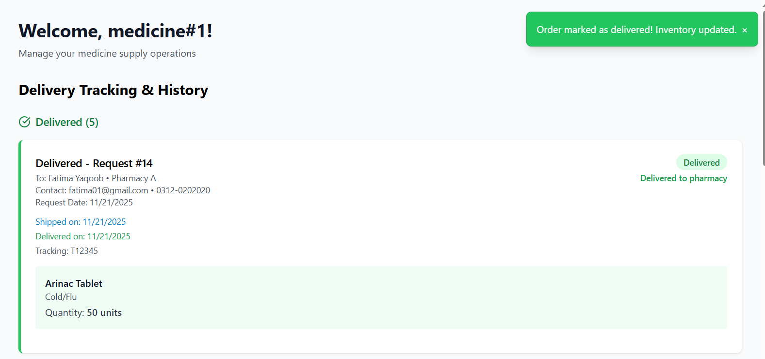

Pharmacist Receives Completed Delivery
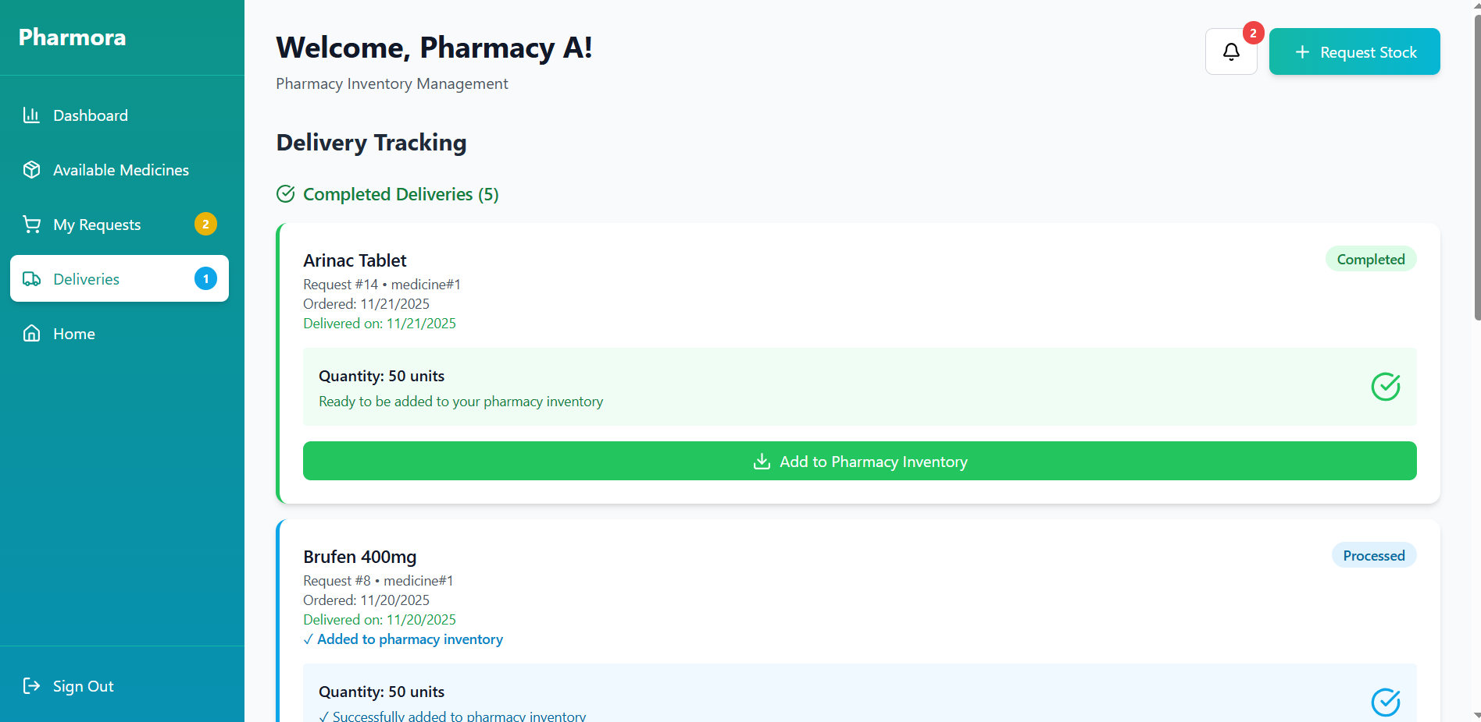

Pharmacist Updates Medicine Inventory
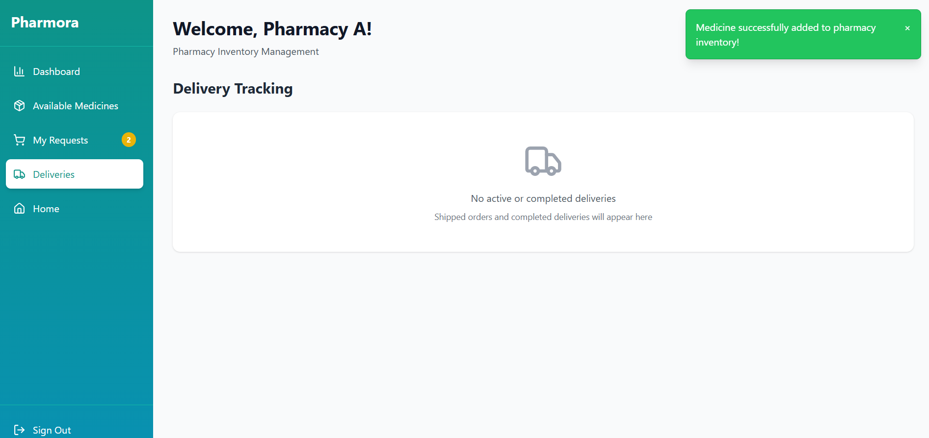

Admin Dashboard
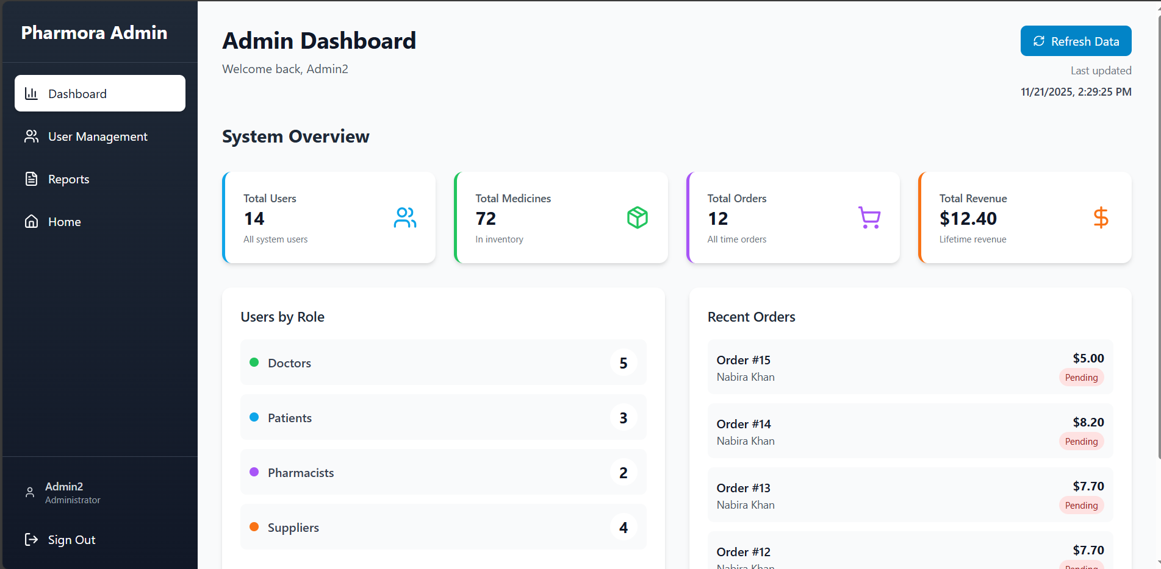

Edit User
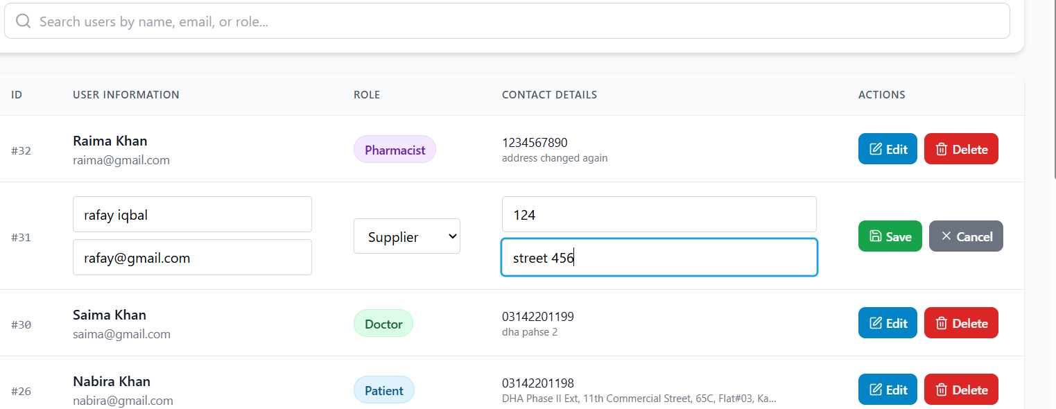
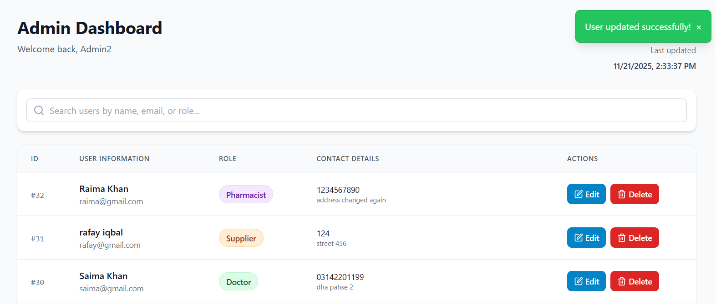

Delete User
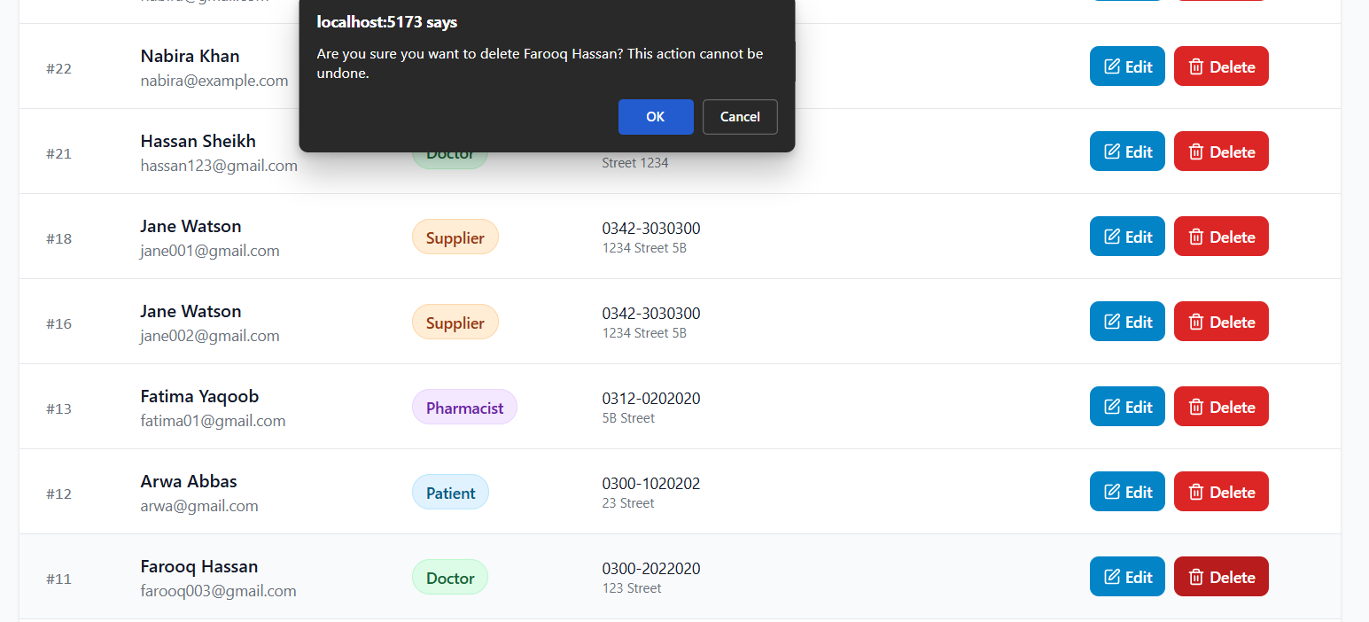
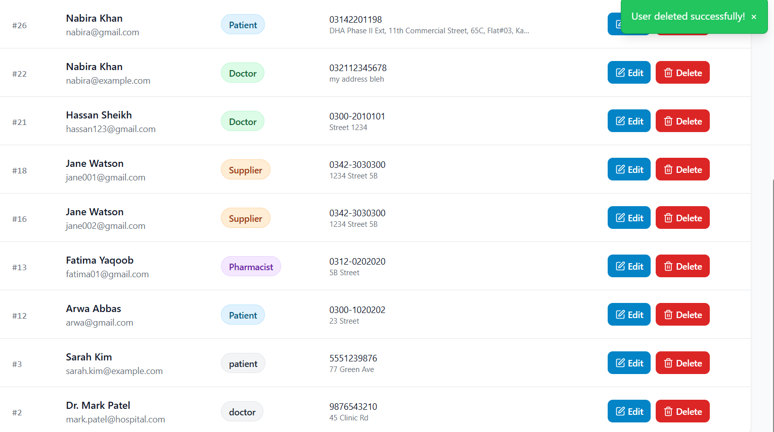

Reports Tab
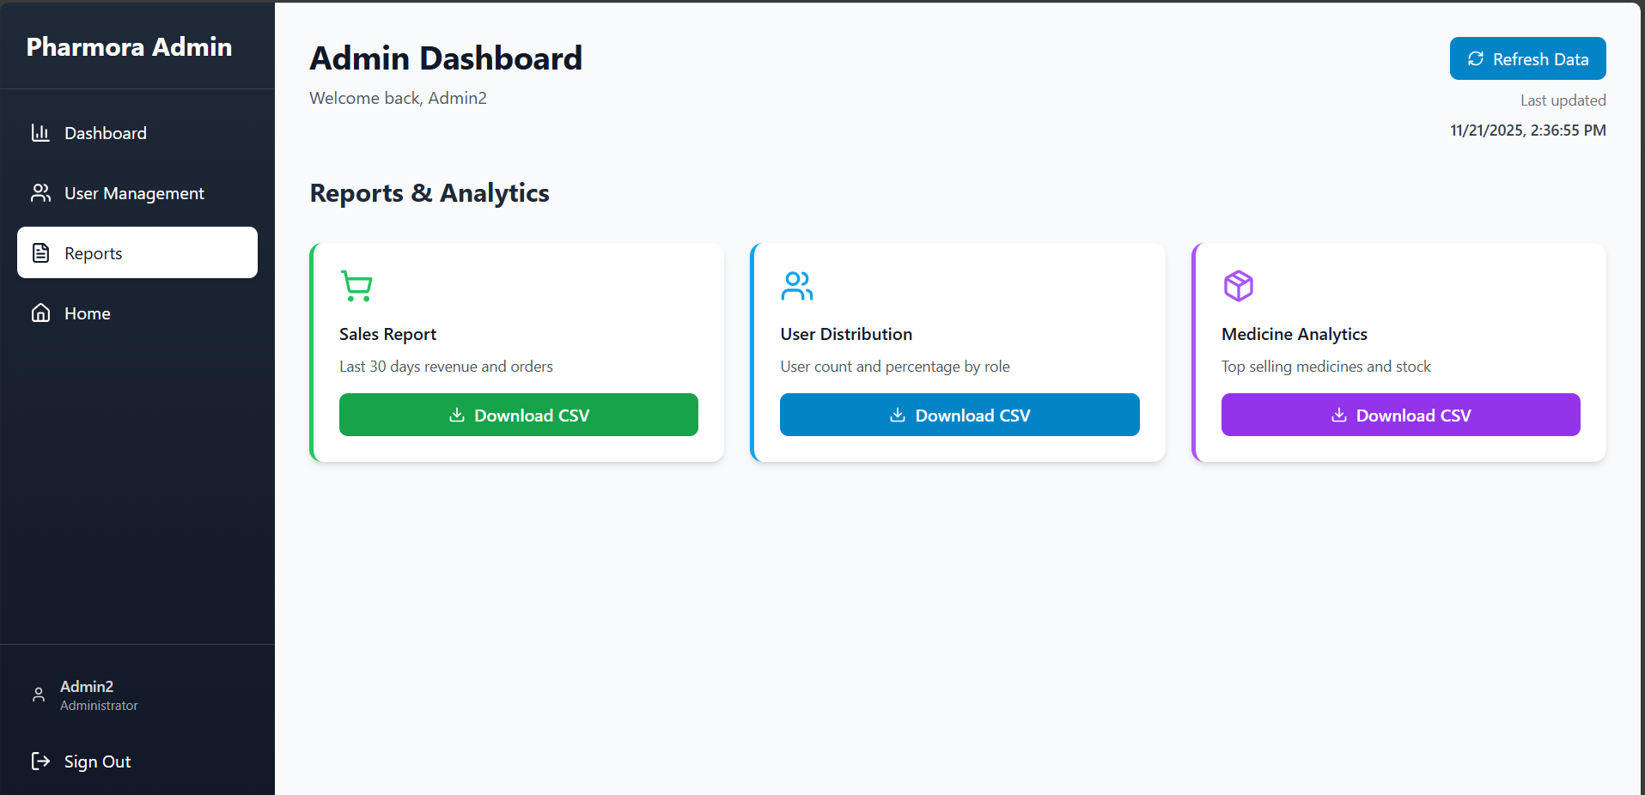

Generate Sales Report
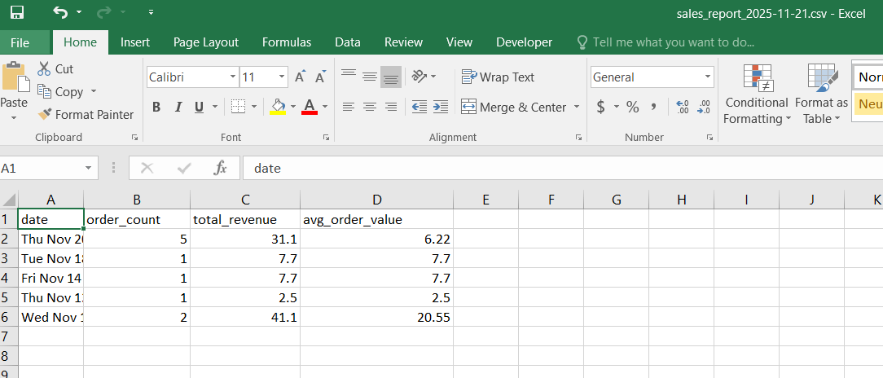

Generate User Roles Count Report
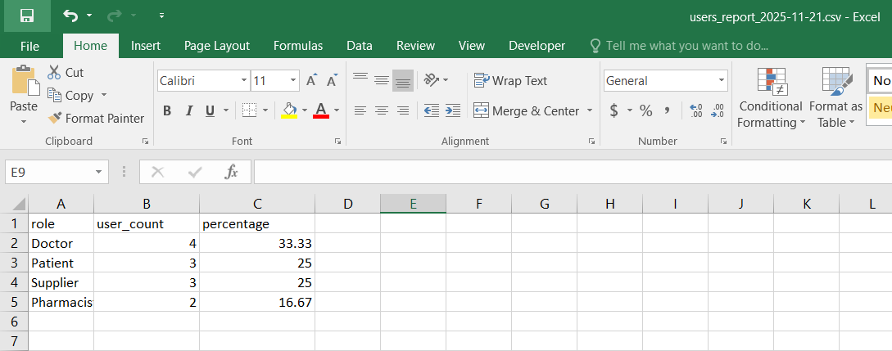

Generate Medicines Stock & Revenue Report
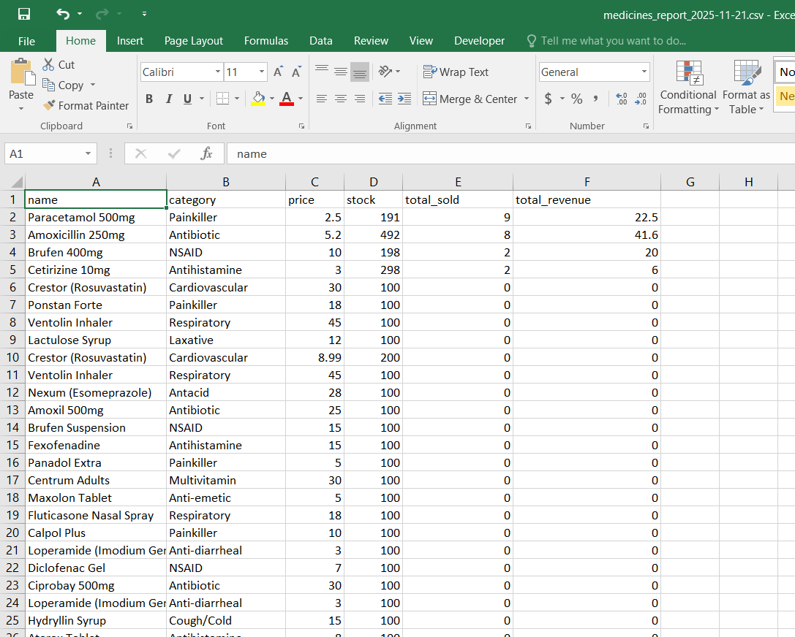

Supabase Setup

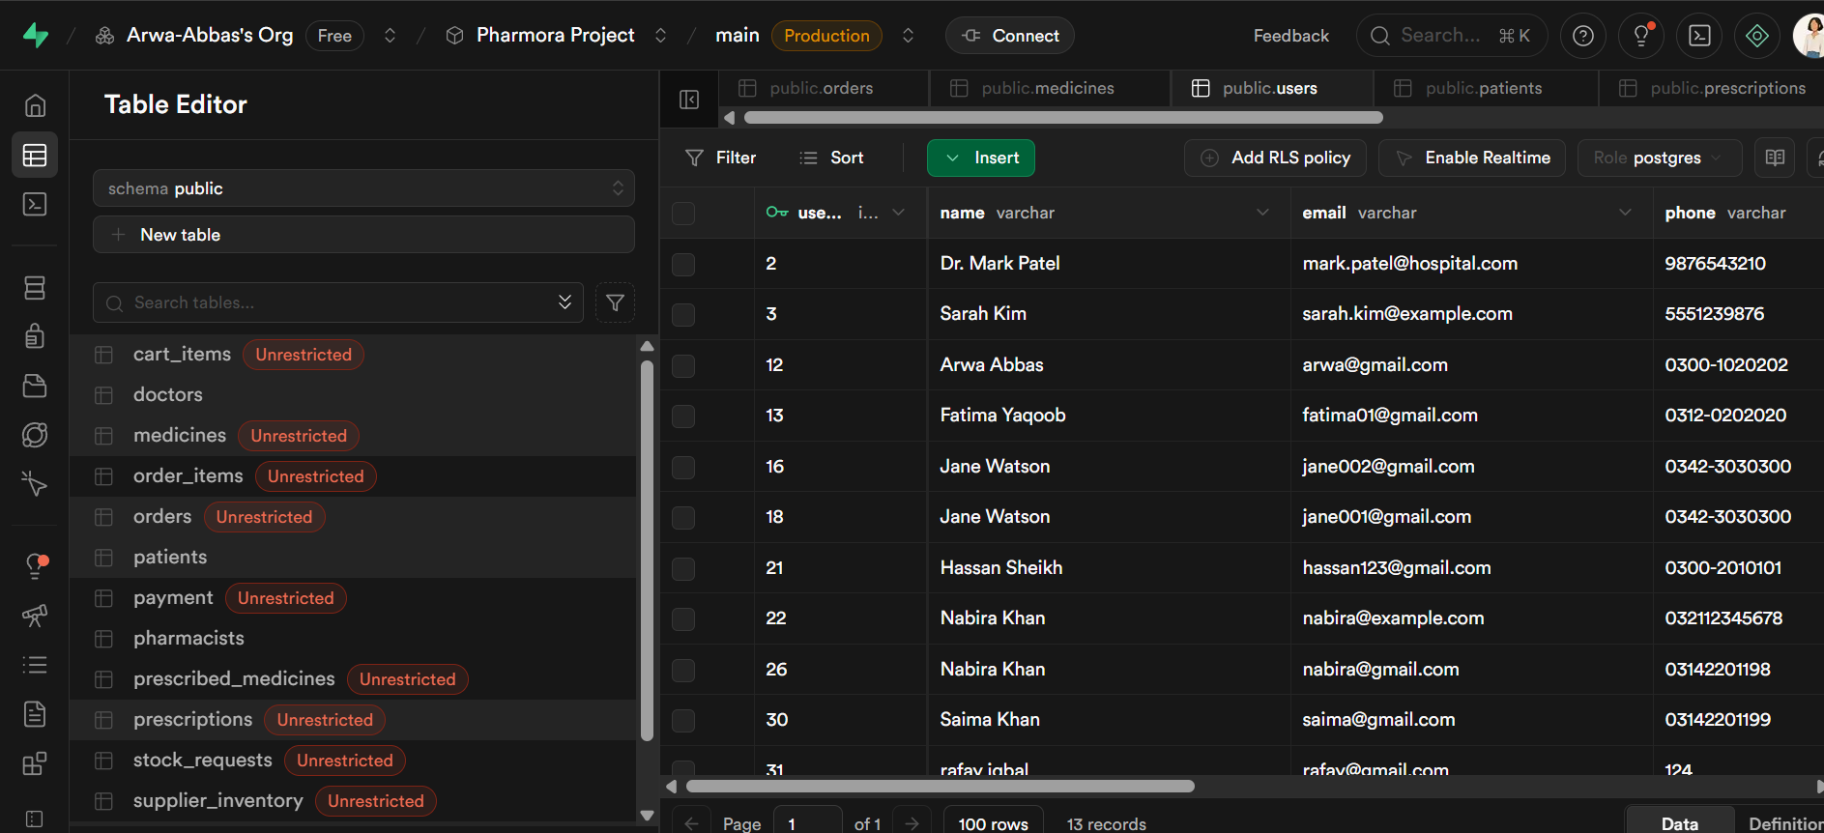
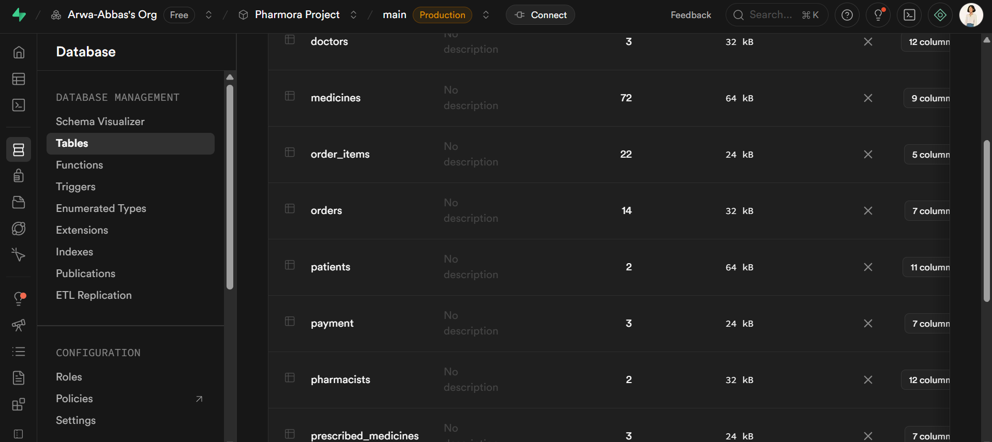

CONCLUSION

Pharmora successfully demonstrates a secure, scalable, and integrated digital solution for modern pharmacy and healthcare management. By combining prescription handling, inventory control, order processing, and role-based access into a single PERN stack platform, the system addresses critical challenges faced by traditional pharmacies, such as manual verification, stock mismanagement, and limited accessibility.

The project highlights the effective collaboration of multiple stakeholders — patients, doctors, pharmacists, suppliers, and administrators — through automated workflows and real-time communication. Implementation and testing phases confirmed that the platform is reliable, user-friendly, and capable of handling concurrent operations while maintaining data security and integrity.

In addition to improving operational efficiency and enhancing patient convenience, Pharmora provides a foundation for future enhancements, such as AI-assisted prescription validation, real-time delivery tracking, and expanded analytics for administrators. Overall, the project demonstrates how technology can streamline healthcare processes, improve transparency, and deliver a modern, digital-first pharmacy experience.

